Contents

Creating the Table 3

**Introduction** 3

**Task 1: Open Quick SQL** 3

**Task 2: Enter Shorthand for Tables** 3

**Task 3: Implement the Script** 5

**Task 4: Create the Application** 6

**Summary** 10

Populating the Table 11

Introduction 11

Background Information 11

Task 1: Create a Script 11

Task 2: Review the Data 14

Summary 15

Improving the Report 17

Introduction 17

Background Information 17

Task 1: Update the Report Query 17

Task 2: Update the Report Columns 20

Task 3: Remove Data Entry Components 21

Task 4: Resequence the Report Columns 23

Task 5: Add a Computation 24

Task 6: Save the Report 26

Summary 27

Adding a Chart 28

Introduction 28

Background Information 28

Task 1: Create a New Page 28

Task 2: Adjust the Chart Attributes 32

Task 3: Update the Chart Series 34

Summary 40

Adding Chart Criteria 41

Introduction 41

Background Information 41

Task 1: Add a Page Item 41

Task 2: Add a Dynamic Action 43

Task 3: Update the Chart 45

Task 4: Improve the Chart Page 46

Summary 48

# Creating the Table

**Introduction**

In this lab, you will learn how to create a table by defining the data structures in Quick SQL.

Estimated Time: 10 minutes

Collapse All Tasks

**Task 1: Open Quick SQL**

1. Log into your workspace.
2. Click **SQL Workshop**.
3. Click **SQL Scripts**.

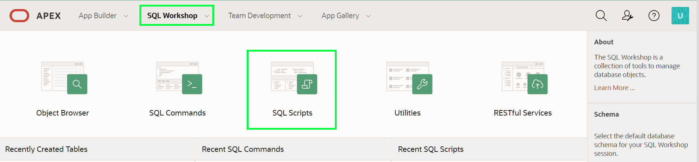

1. Click **Quick SQL**.

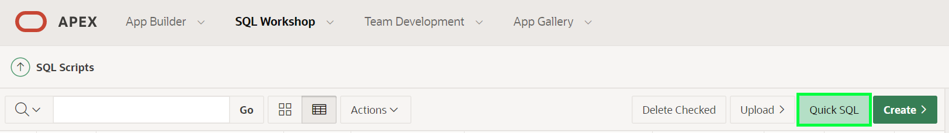

**Task 2: Enter Shorthand for Tables**

Quick SQL provides an easy way to generate the SQL required to create a relational data model from an indented text document. This tool is designed to reduce the time and effort required to create SQL tables, triggers, and index structures.

1. In Quick SQL (left pane), enter the following.
2. Copy**big_mac_index**
3. country_name
4. country_iso
5. currency_code
6. local_price num
7. dollar_exchange_rate num
8. gdp_dollar num

entry_date

*Note: By indenting the country_name and subsequent rows, it is indicating that these are columns for the table, big_mac_index, defined in the first row.*

Click **Generate SQL**.

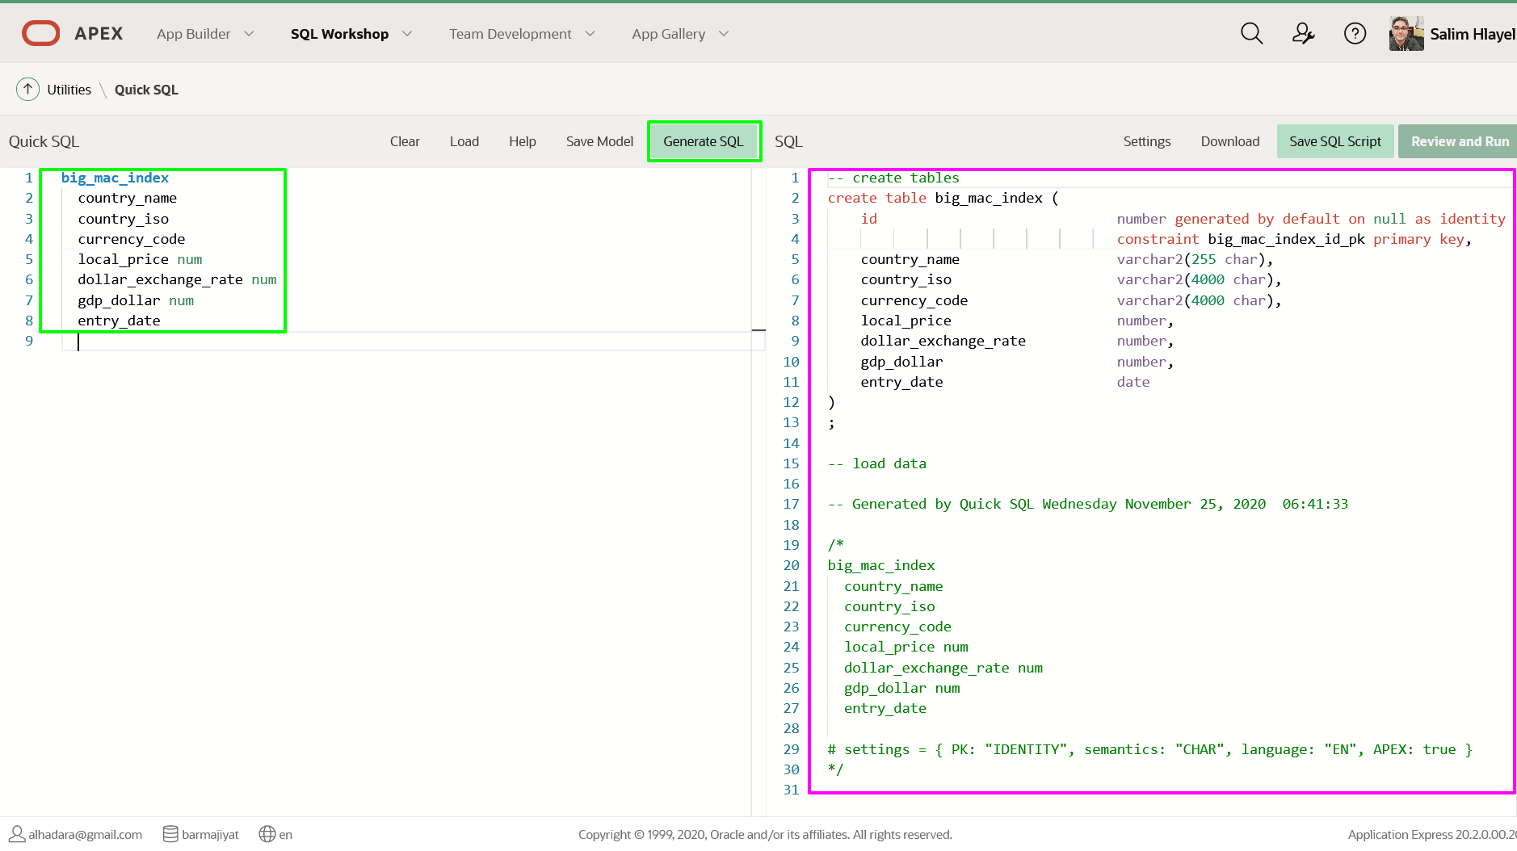

**Task 3: Implement the Script**

At this stage you have created a SQL statement. However, you first need to save the statement as a script file and then run the script. This will create the database object you defined.

1. In the SQL (right pane) toolbar, click **Save SQL Script**.
2. In the Save Script dialog, for Script Name, enter **remote**.  
   Click **Save Script**.

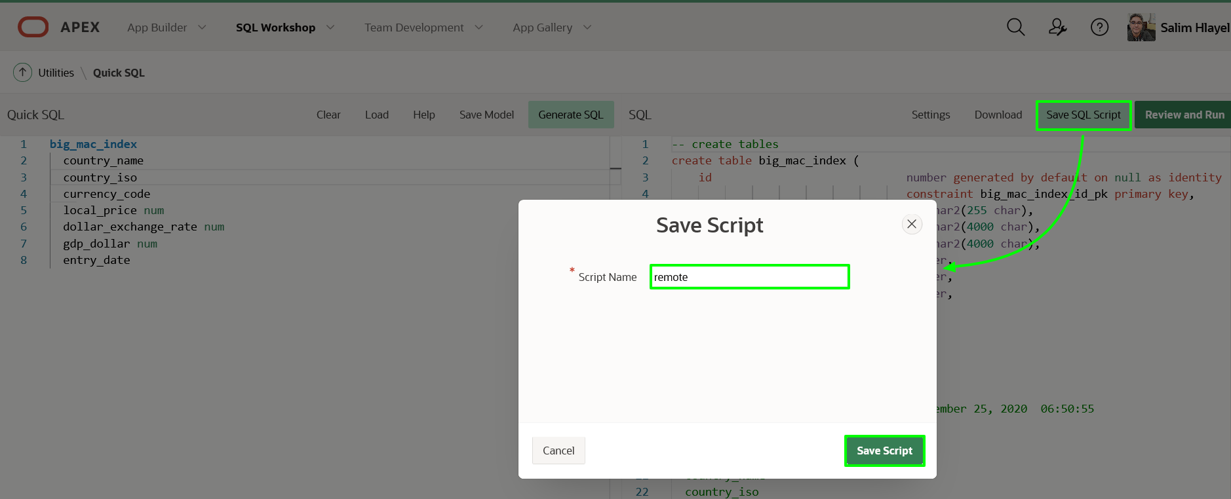

1. In the SQL (right pane) toolbar, click **Review and Run**. The script will be displayed in the **Script Editor**, within SQL Scripts.

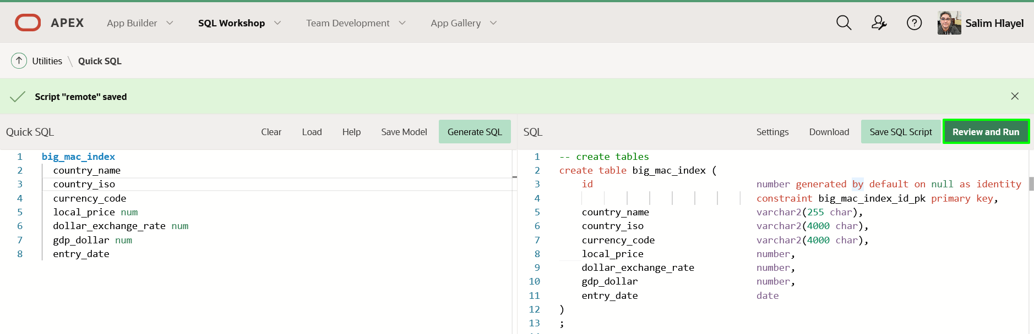

Click **Run**.

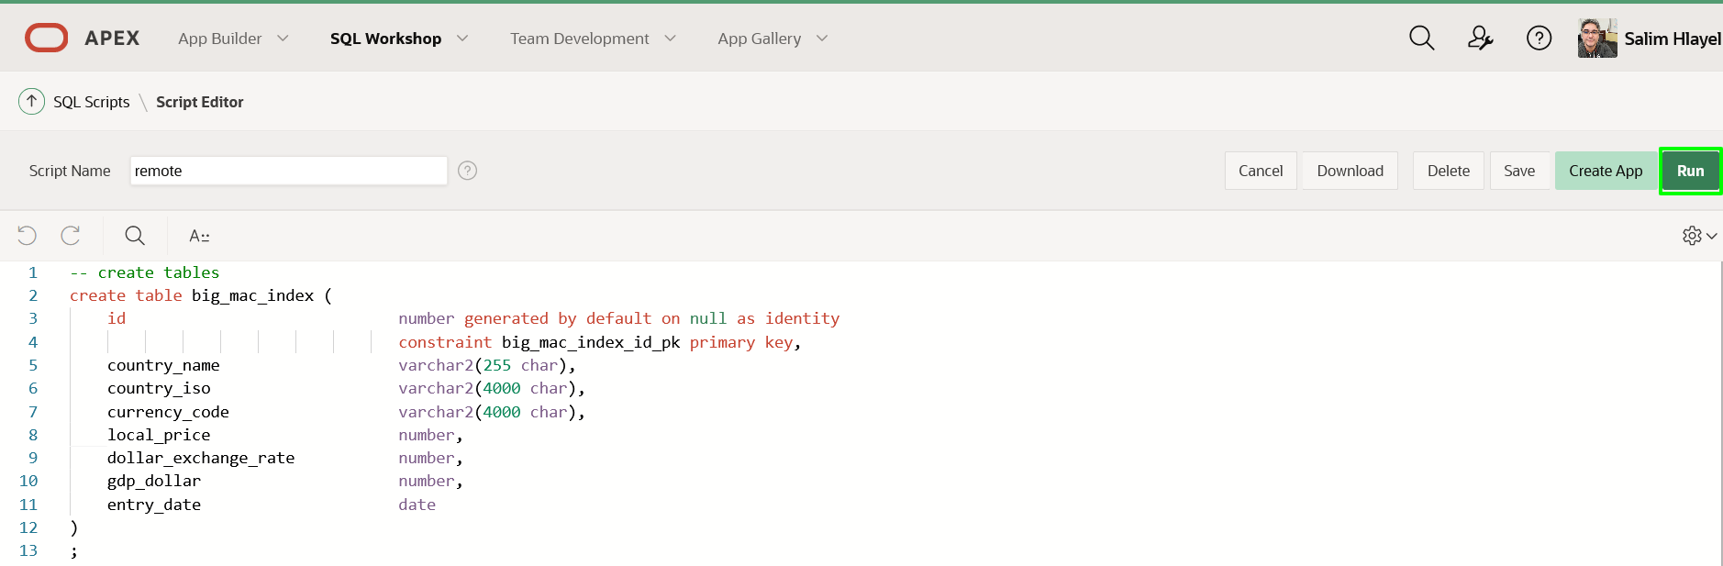

1. On the Run Script page, click **Run Now**.
2. The Script Results page will be displayed listing the statements processed, successful, and with errors.

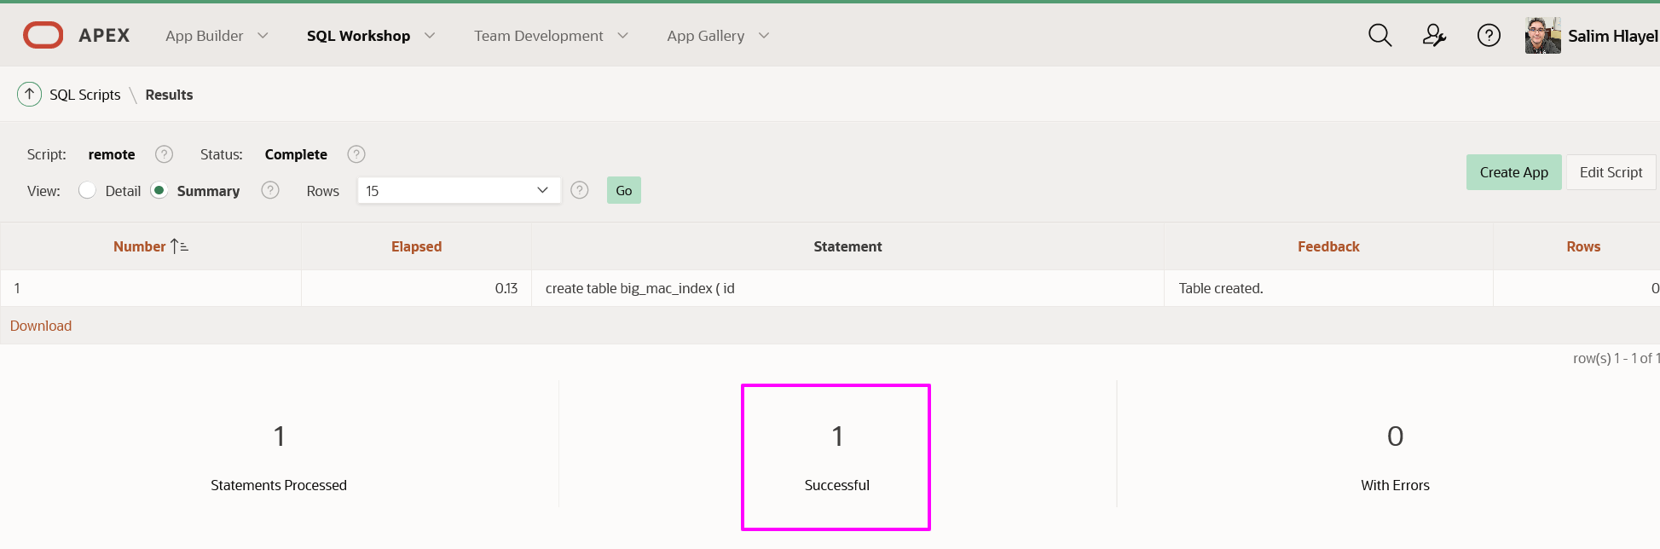

*Note: If you do not see 1 statements processed then return to Quick SQL and click Generate SQL, reimplement the Setting, resave the script and then run it again. If you still do not see 1 successful, then review the errors displayed in Feedback within the results.*

**Task 4: Create the Application**

Now that you have created the table you can quickly create an application with a report and form.

1. Click **Create App**.

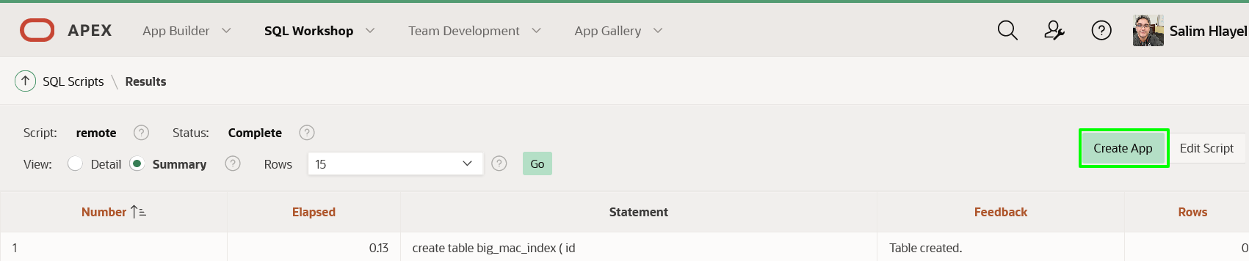

*Note: If you are back on SQL Scripts, and don’t see the “Create App” button perform the following steps.*  
*1. Within the Results column, click “1” for the script you just ran.*  
*2. Under View Results, click the magnifying glass.* *The results page shown above should now be displayed again.*

1. In the Create App from Script dialog, click **Create Application**.

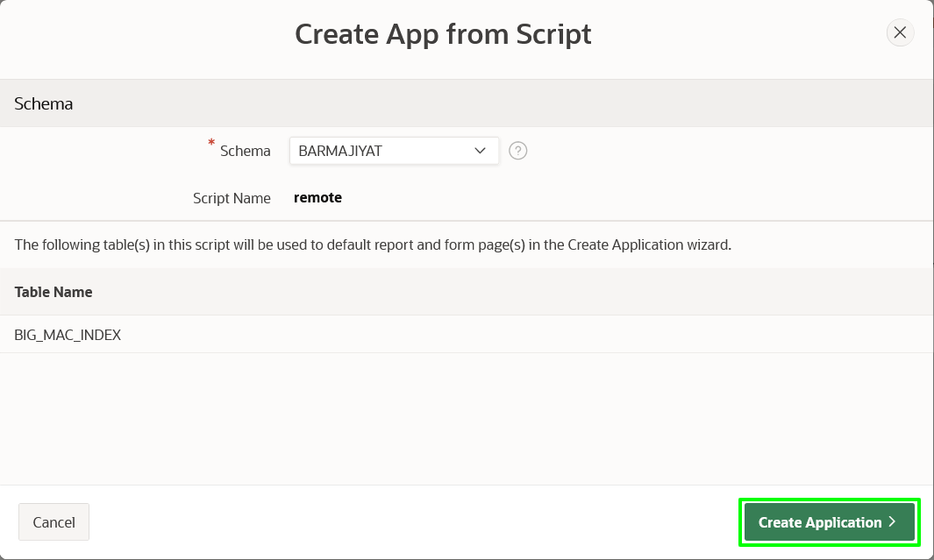

1. In the Create an Application page, enter the following.
   * **Name:** enter **Global Exchange**
   * **Features:** click **Check All**

At the bottom of the page, click **Create Application**.

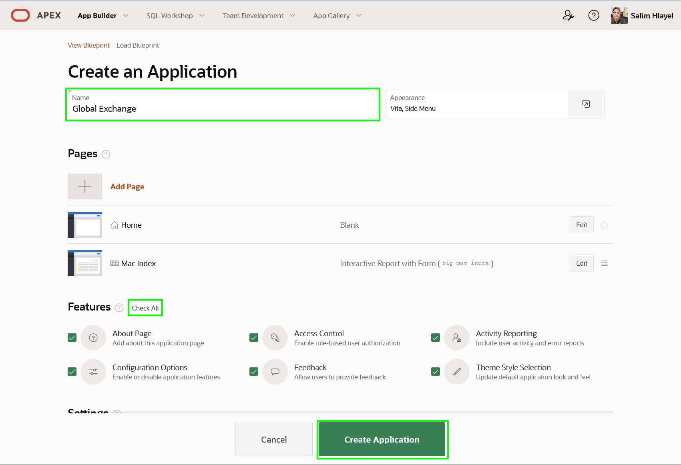

1. Your new application will be displayed in Page Designer.
2. Click **Run Application**.

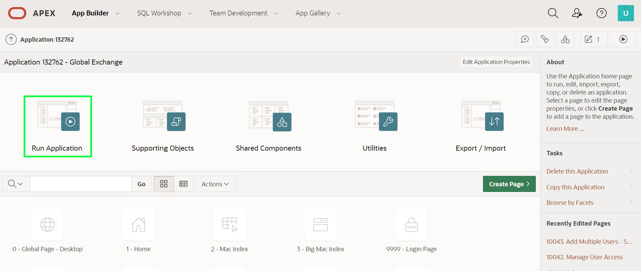

1. In the runtime environment, on the login page, enter your credentials.

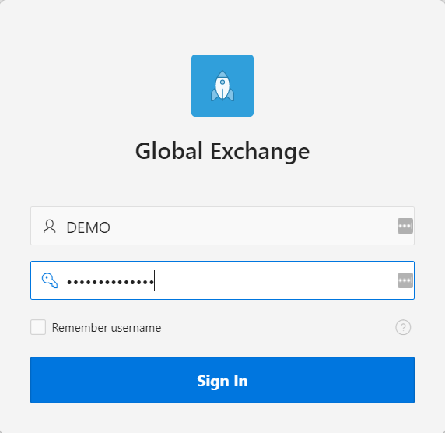

1. Play around with your new application.

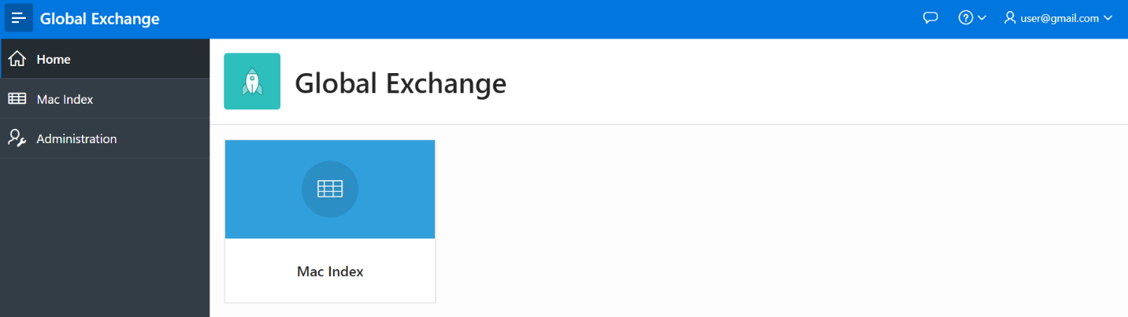

*Note: When you click on Mac Index there will be no data displayed. You don't want to manually enter in data as the table will be populated in the next lab.*

**Summary**

This completes Lab 2. You now know how to utilize Quick SQL to build a simple table and create an application on top of it.

# Populating the Table

## Introduction

In this lab, you will learn how to insert data into a table from a REST API.

Estimated Time: 5 minutes

### Background Information

The **apex_data_parser** is a PL/SQL package which provides an easy interface to parse files from various file formats, including comma-delimited (.csv). The parser is implemented as a table function - so the developer accesses parser results like a table. Therefore, the parser can utilize INSERT … SELECT statements to insert rows directly into a table from the specified file.

The **apex_web_service.make_rest_request_b** is a PL/SQL function which invokes a RESTful style Web service and returns the results in a BLOB. Utilizing this function within apex_data_parser will allow you to load data from a REST API directly into your table.

Collapse All Tasks

## Task 1: Create a Script

Rather than running a one-off SQL statement to load the data, writing a SQL Script enables the SQL statement to be run repeatedly.

The Big Mac Data is refreshed every 6 months. Therefore, this script can be used twice a year to keep the data current.

1. From the runtime environment, in the Developer Toolbar (bottom of screen), click **Home**.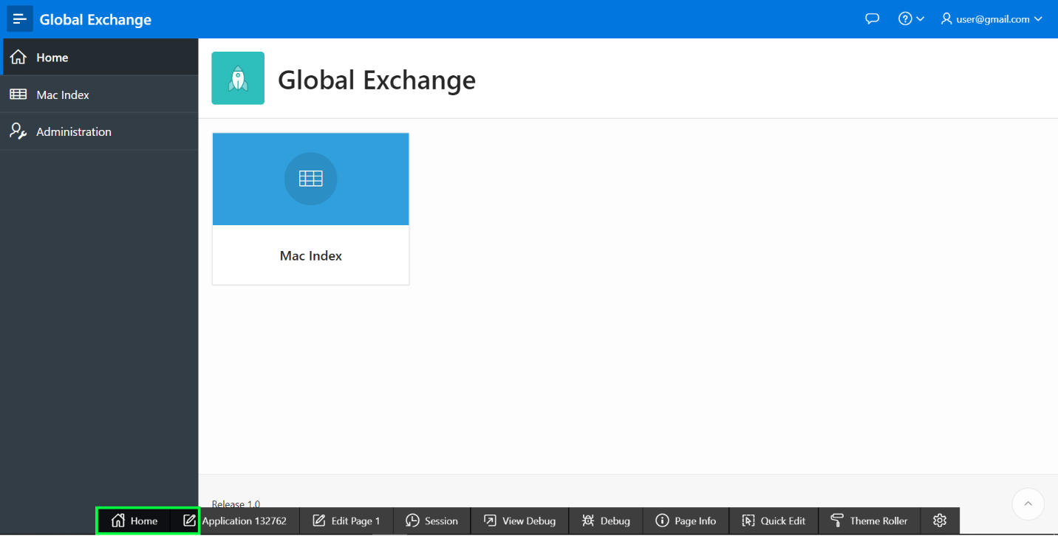
2. Click **SQL Workshop**, and then select **SQL Scripts**.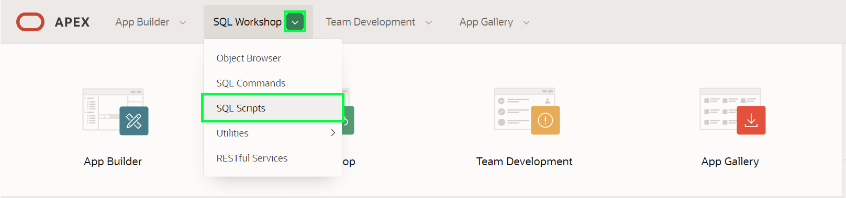
3. In the SQL Script page toolbar, click **Create**.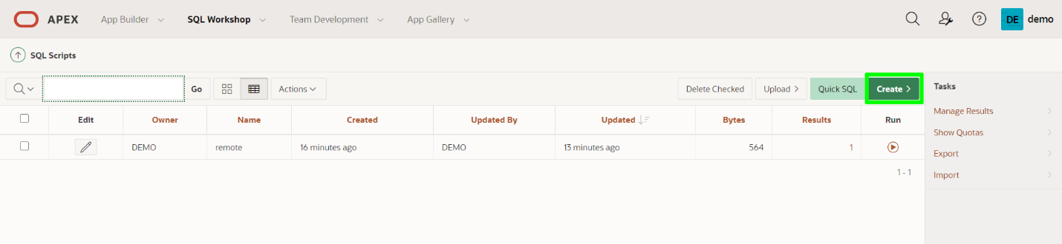
4. In the Script Editor page, enter the following.
   * **Script Name:** enter **Populate BIG_MAC_INDEX**
   * Copy and paste the following.
5. Copy-- Remove current data
6. **delete** big_mac_index;
7. -- Load data from The Economist (csv) REST API
8. **insert** **into** big_mac_index
9. (country_name, country_iso, currency_code, local_price, dollar_exchange_rate, gdp_dollar, entry_date)
10. **select** col001, col002, col003, col004, col005, col006, to_date(col007,'YYYY-MM-DD')
11. **from** **table**(apex_data_parser.parse
12. ( p_content => apex_web_service.make_rest_request_b
13. ('https://raw.githubusercontent.com/TheEconomist/big-mac-data/master/source-data/big-mac-source-data.csv', 'GET')
14. , p_file_name => 'big-mac-source-data.csv'
15. , p_skip_rows => 1
16. ));
17. -- Delete bad data (rows with no price)
18. **delete** big_mac_index

**where** local_price = 0;

1. Click **Run**.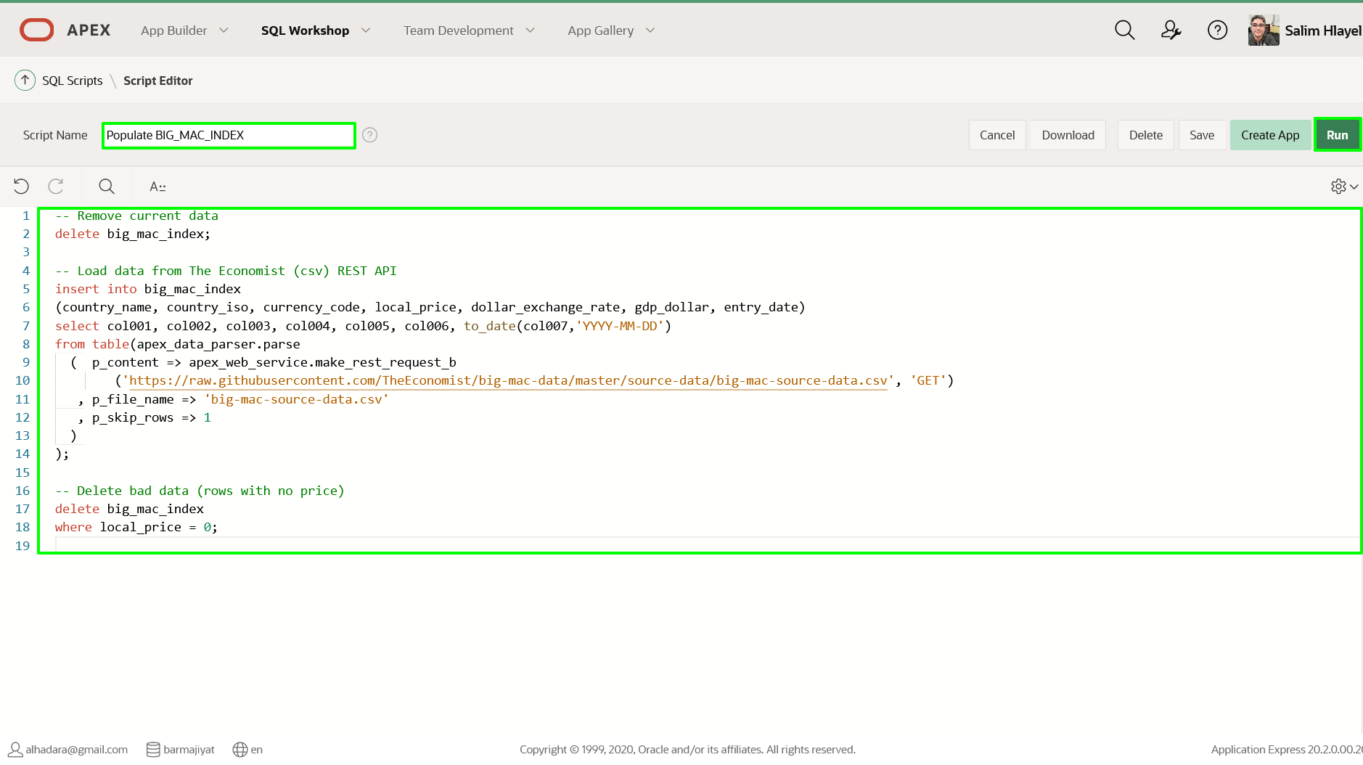
2. On the Run Script page, click **Run Now**.
3. The Script Results page will be displayed listing the statements processed, successful, and with errors. In November 2020, Results should show **1658 row(s) inserted** and **1 row(s) deleted**(your number of rows inserted/deleted may differ depending on the date you run the script).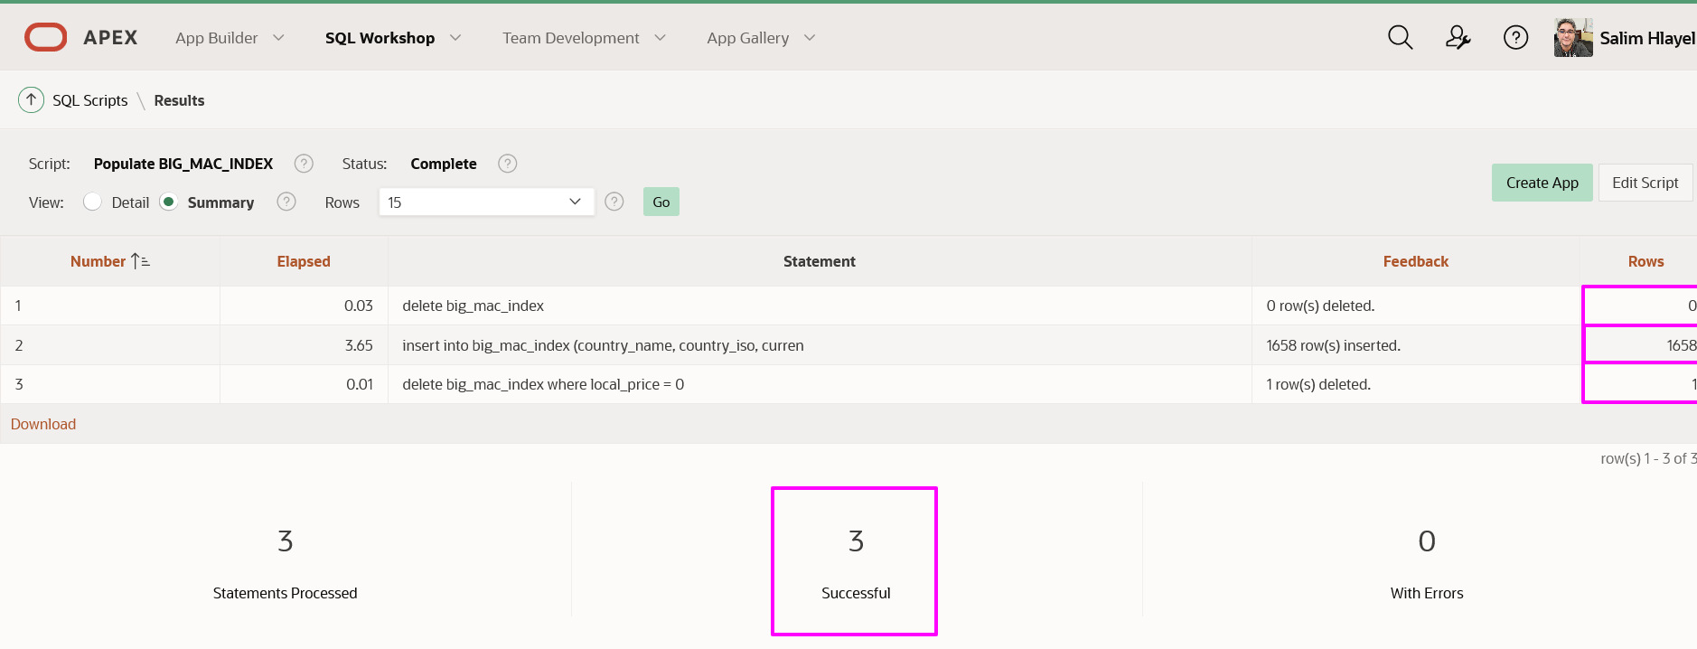Note: If you do not see 3 statements processed successfully then double check your table definition and the script to populate the table.

## Task 2: Review the Data

There are several ways to review the data.

1. Navigate to the runtime environment tab or window.
2. In the application menu click **Mac Index**. On the report, click **Entry Date**, and click **Sort Ascending**, to see the latest data.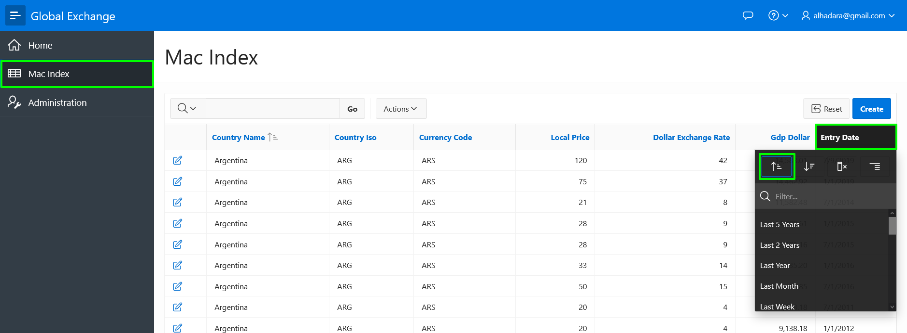Note: Many of the Dollar Exchange Rate values simply show 1.
3. In the APEX Builder tab or window, click **SQL Workshop**, and then select **Object Browser**.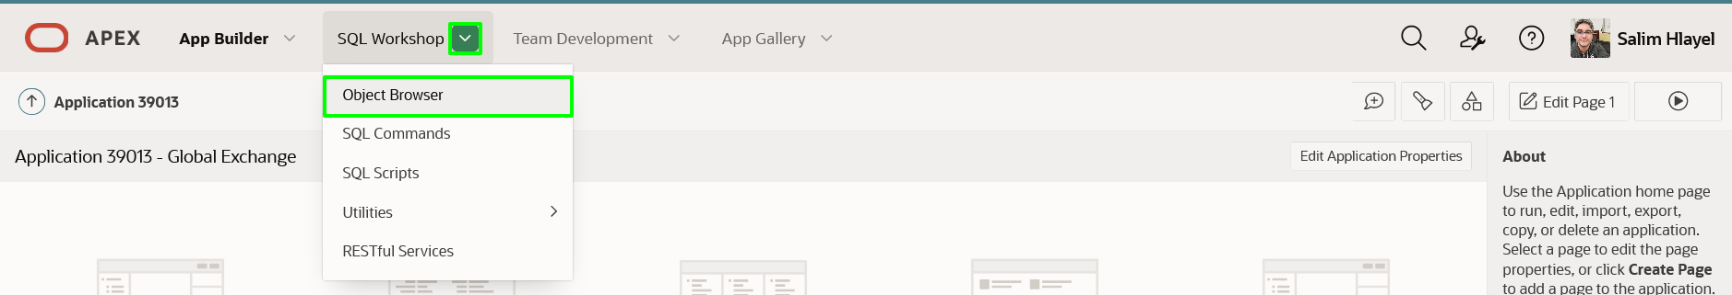
4. In Object Browser, within the list of Tables, click **BIG_MAC_INDEX**. In the middle pane, click **Data**.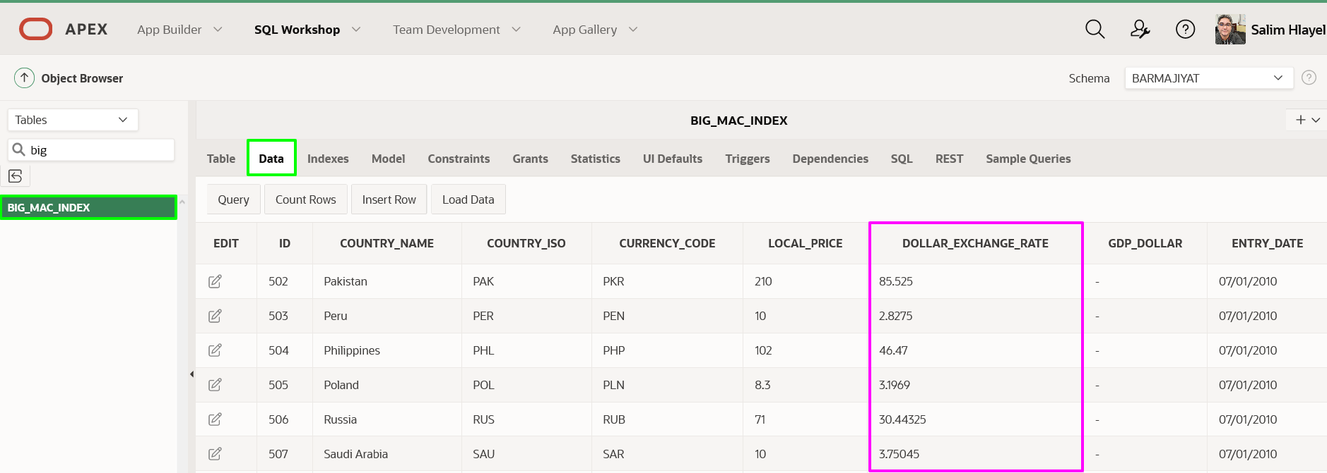Note: Review the decimal places on the DOLLAR_EXCHANGE_RATE column. In the next lab you will ensure the data displays properly.

## ****Summary****

This completes Lab 3. You now know how to utilize **apex_data_parser** and **apex_web_service.make_rest_request_b** to populate a table in the Oracle database based on a REST endpoint.

# Improving the Report

## Introduction

In this lab, you will learn how to manipulate an Interactive Report to improve the data displayed and make it easier for users to analyze the data.

Estimated Time: 15 minutes

### Background Information

Now you have data loaded into the BIG_MAC_INDEX table you can start reviewing the local price of a McDonalds Big Mac and the exchange rate with the US Dollar.

For any given country, if you divide the Local Price of a Big Mac by the Local Price of a Big Mac in the US, for the same time period, you can calculate the relative exchange rates between the countries based on the Big Mac prices.

If you then subtract the Dollar Exchange Rate from the relative exchange rate, and divide by the Dollar Exchange Rate, then you can determine if the currency is overvalued (positive) or undervalued (negative), against the US Dollar.

While this is not an exact determination of if a currency is overvalued or undervalued against the US Dollar, it is a good approximation using a product which is generally available in most countries.

Collapse All Tasks

## Task 1: Update the Report Query

When the application was generated it utilized the standard table columns. By converting it to a SQL Query and updating the SQL you can include the relative exchange rate to make it easier for people to review the data.

1. From Object Browser, in the APEX Builder Toolbar, click **App Builder**, and then select **Database Applications**.

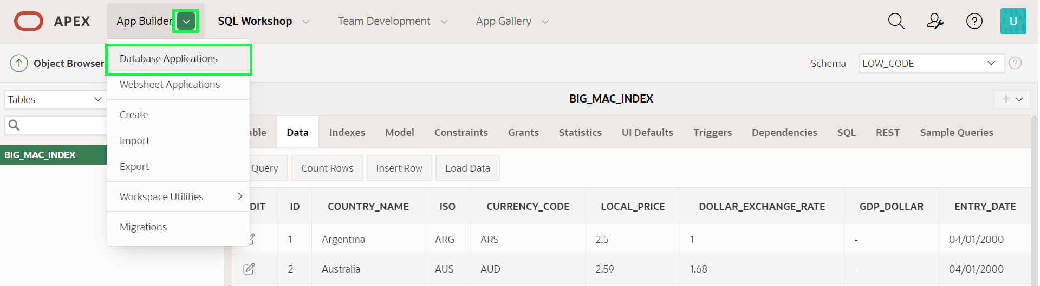

1. In the list of applications, click **Global Exchange**.

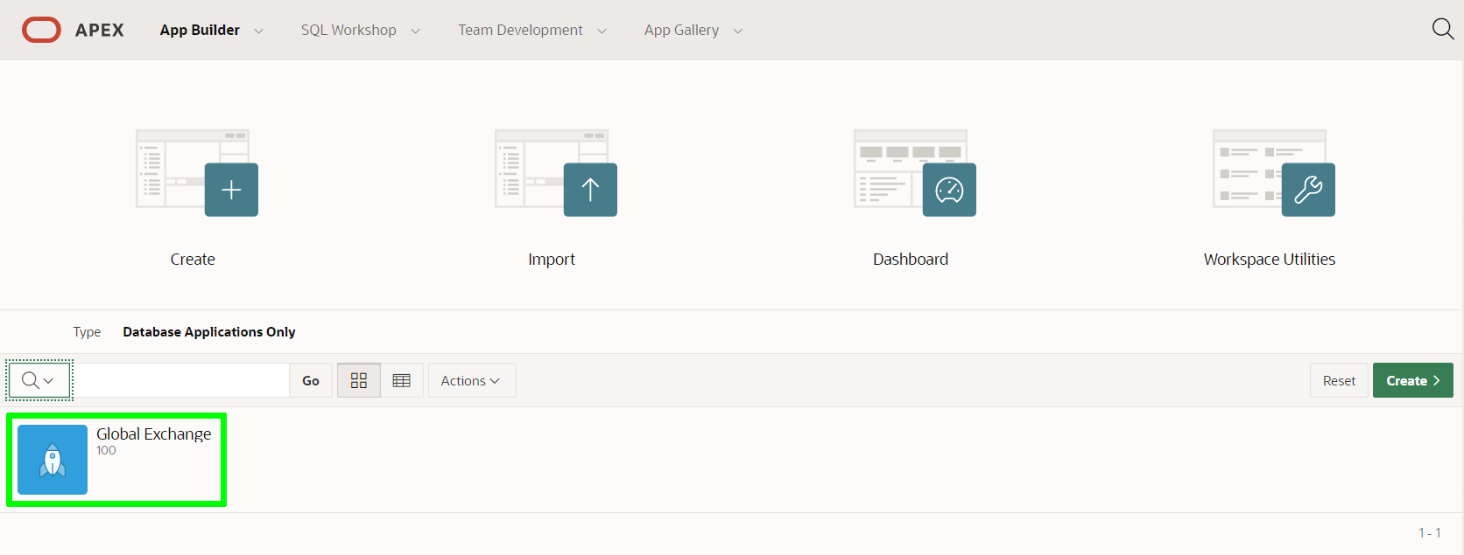

1. From the app home page, click **2 – Mac Index**, which will take you to Page Designer and load Page 2, the report page.

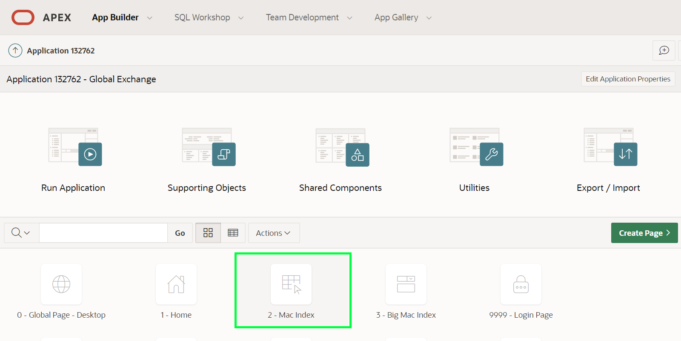

1. Within Page Designer, in the Rendering tree (left pane), under Content Body, click **Big Mac Indexes** (This is the report region).

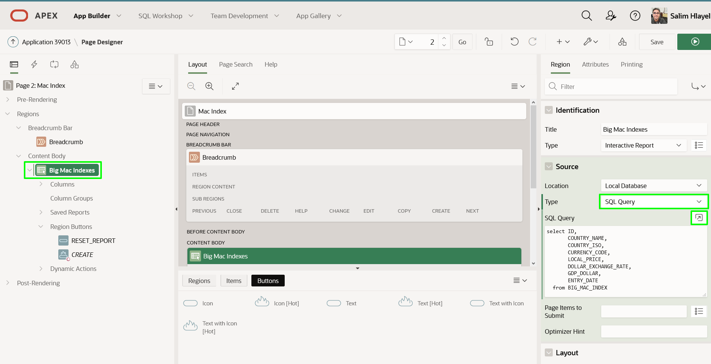

In the Property Editor (right pane), enter the following.

* + **Source > Type:** select **SQL Query**
  + **Source - SQL Query:** click the **Code Editor** icon, and cut and paste the following.
  + Copy**select** ID,
  + COUNTRY_NAME,
  + COUNTRY_ISO,
  + CURRENCY_CODE,
  + LOCAL_PRICE,
  + DOLLAR_EXCHANGE_RATE,
  + ENTRY_DATE,
  + (local_price / (**select** local_price **from** big_mac_index u
  + **where** u.entry_date = l.entry_date
  + **and** u.country_iso = 'USA'
  + )
  + ) relative_exchange_rate

**from** BIG_MAC_INDEX l

Click **Validate** – Validation Successful will be displayed.  
Click **OK**.

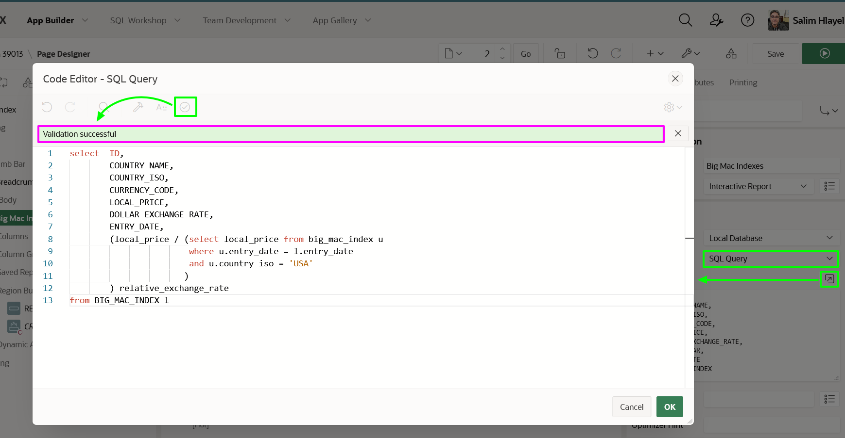

Note: The gdp_dollar column was removed as it is not needed. The inner select is used to get the US price for the same date, in order to calculate the relative exchange rate.

## Task 2: Update the Report Columns

Individual report columns need a better format mask to properly display the data.

1. In the Rendering tree (left pane), click **Columns**. Within the list of columns, click **LOCAL_PRICE**.

In the Property Editor (right pane), click the select icon for Appearance > Format Mask. In the Pick Format Mask dialog, select **5,234.10**.

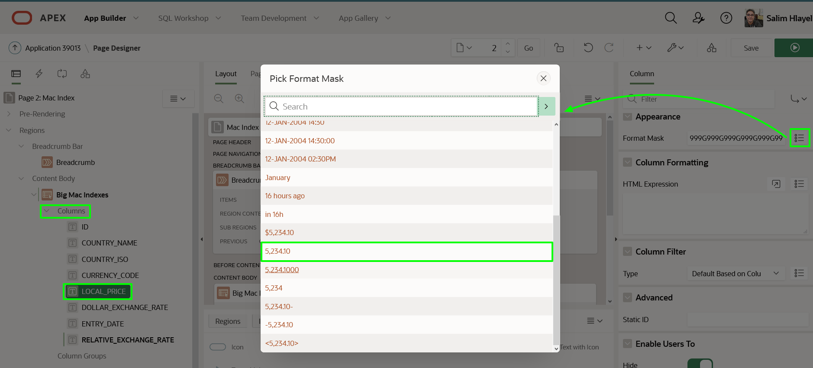

1. In the Rendering tree (left pane), within the list of columns, click **DOLLAR_EXCHANGE_RATE**.

In the Property Editor (right pane), click the select icon for Appearance > Format Mask. In the Pick Format Mask dialog, select **5,234.1000**.

1. In the Rendering tree (left pane), within the list of columns, click **RELATIVE_EXCHANGE_RATE**.

In the Property Editor (right pane), click the select icon for Appearance > Format Mask. In the Pick Format Mask dialog, select **5,234.1000**.

## Task 3: Remove Data Entry Components

Given the data is obtained from an external source (The Economist REST API) users of the application should not update or delete existing records, and should not create new records.

1. Remove the edit icon so end users cannot update or delete records.

In the Rendering tree (left pane), under Columns, click **Attributes**. In the Property Editor (right pane), for Link > Link Column, select **Exclude Link Column**.

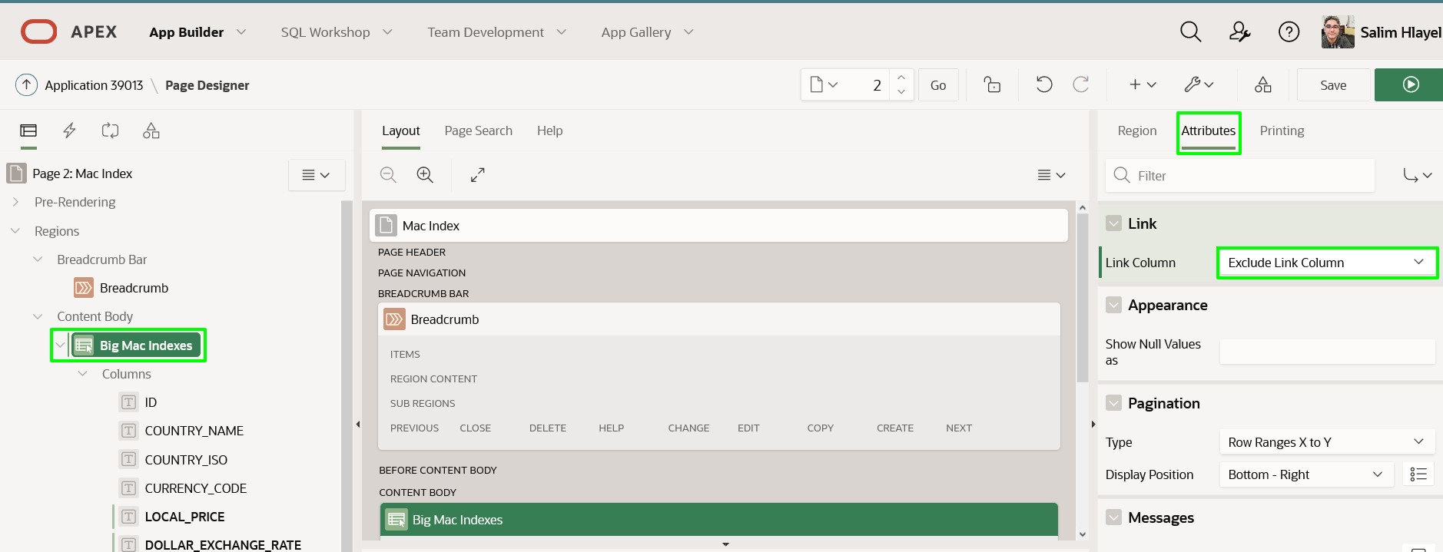

1. Remove the Create button so end users cannot add new records.

In the Rendering tree (left pane), under Region Buttons, right-click **CREATE**, and select **Delete (Del)**.

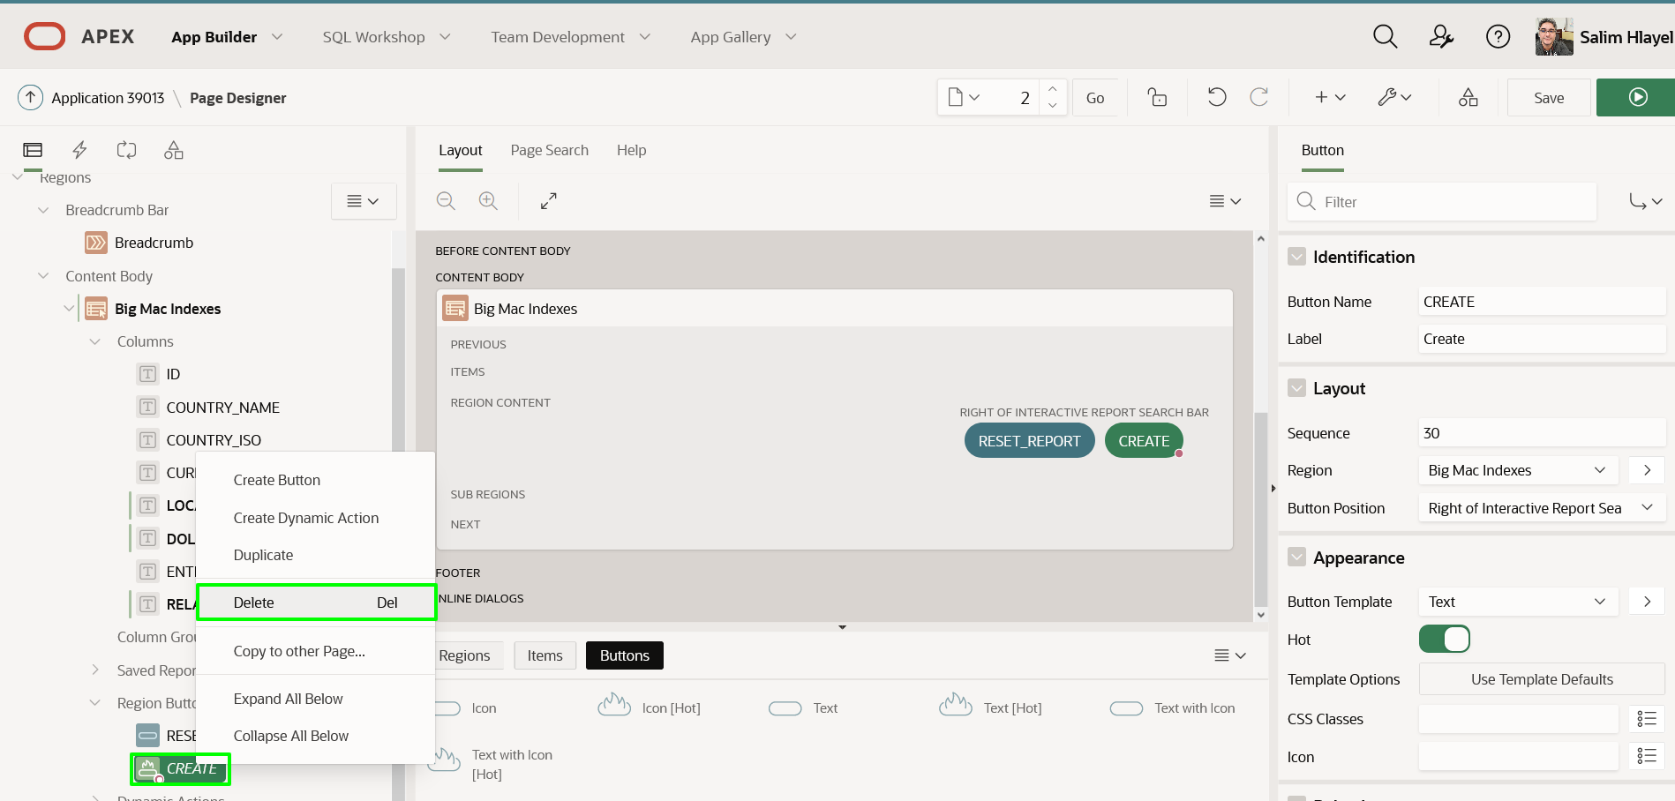

1. It is best, but not mandatory, to remove the Big Mac Index form page altogether.  
   Before moving to Page 3 it is necessary to save the changes you made on Page 2.

In the Page Designer toolbar, with Page 2 selected, click **Save**.  
In the Page Designer toolbar, use the page selector, or down arrow, to navigate to **Page 3 - Big Mac Index**.

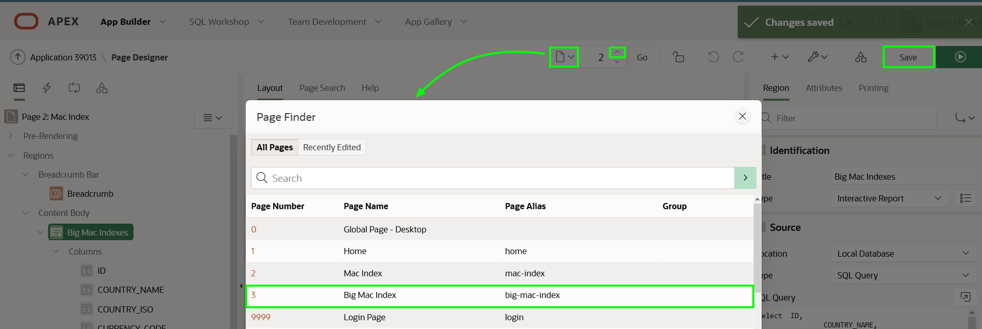

1. On Page 3: Big Mac Index, in the Page Designer toolbar, click **Utilities** (wrench), and then select **Delete Page**.

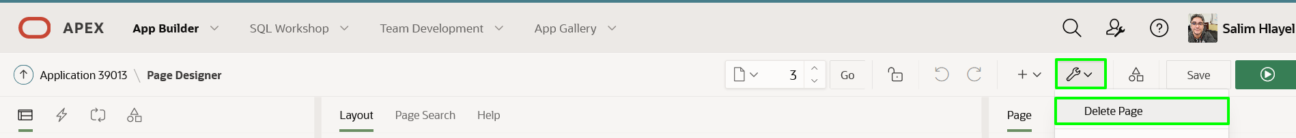

1. On the Confirm Page Delete page, click **Permanently Delete Page**.

Note: Page Designer will return to displaying Page 1: Home.

## Task 4: Resequence the Report Columns

To resequence the order in which the columns are displayed you need to run the report, and then rearrange the column order in the runtime environment.

1. In the Page Designer Toolbar, click **Save and Run**.

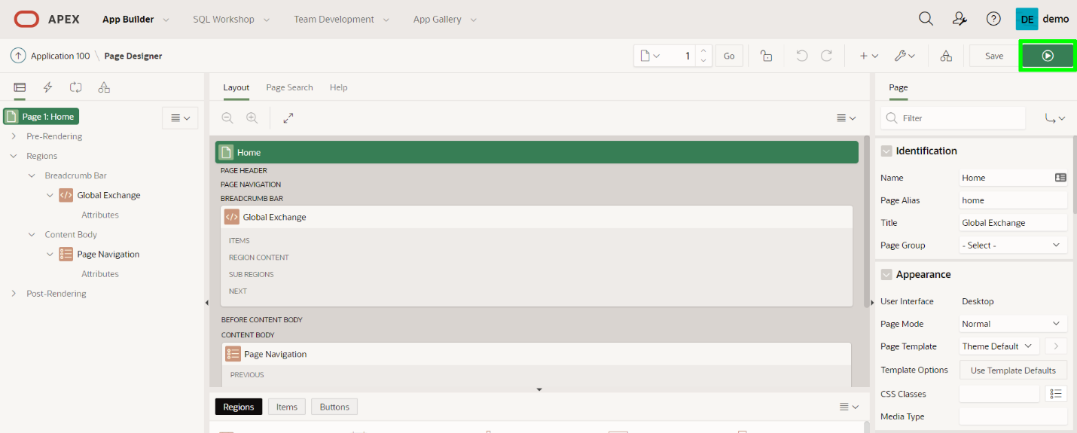

1. In the runtime environment, click **Actions**, then click **Columns**.

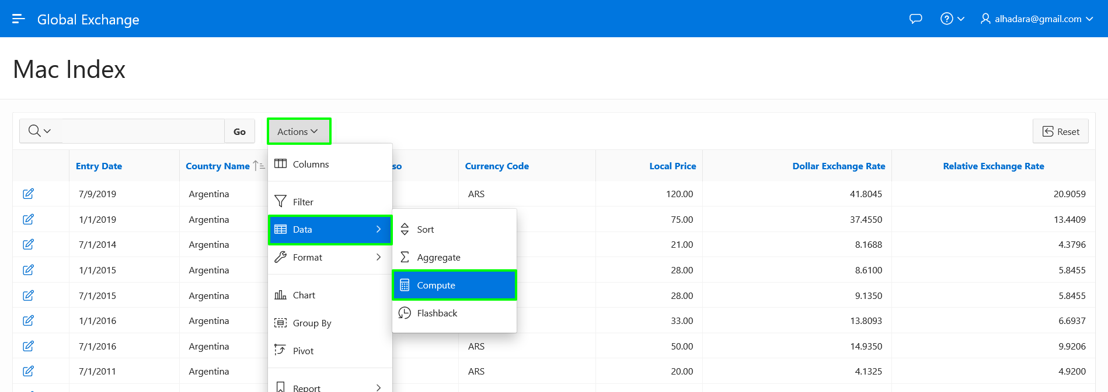

1. In the Select Columns Dialog, select **Entry Date**, and then click **Top**.

Click **Apply**.

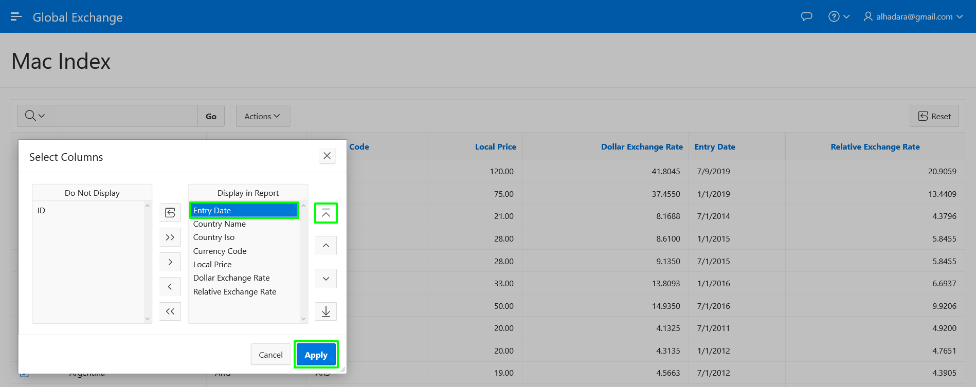

## Task 5: Add a Computation

Rather than adding an additional column to the SQL Query for the region, it is also possible to define computational columns from the runtime environment.

The report contains the Dollar Exchange Rate and Relative Exchange Rate columns. If you subtract the Dollar Exchange Rate from the Relative Exchange Rate and then divide that by the Dollar Exchange Rate, you can calculate the valuation of the currency. It is best to display this as a percentage by multiplying the result by 100.

1. In the runtime environment, click **Actions**, select **Data**, then click **Compute**.

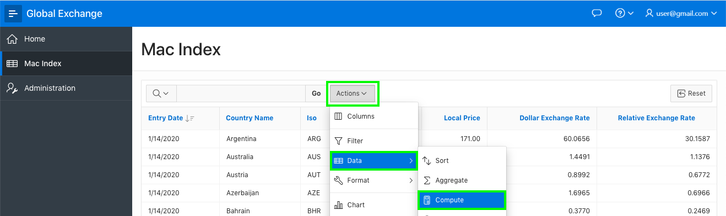

1. In the Compute dialog, enter the following.
   * **Column Label:** enter **Difference %**
   * **Format Mask:** select **5,234.10**
   * **Computation Expression:** enter the following.

Copy(I - F) * 100 / F

Click **Apply**.

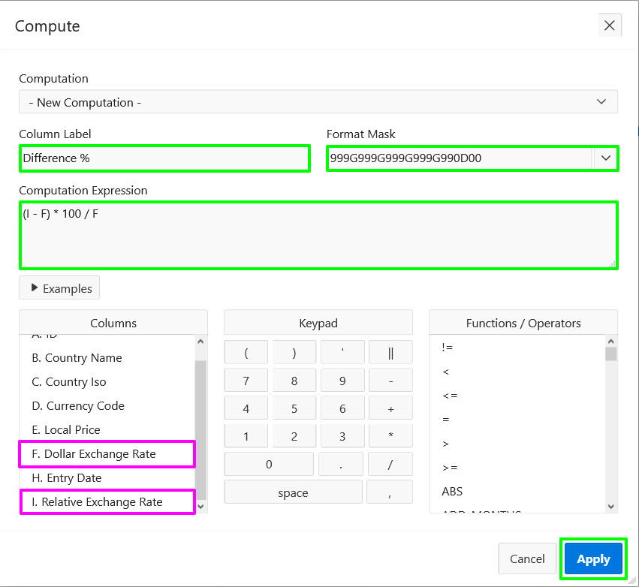

Note: F references Dollar Exchange Rate and I references Relative Exchange Rate as listed under Columns

## Task 6: Save the Report

Currently the changes you have made in the runtime environment can only be seen by you. Further, if you were to log out of the runtime environment and log back in your changes would be lost. In order for everyone to see the revised report you need to save the report as the "Primary" report.

1. In the runtime environment, click **Actions**, select **Report**, then click **Save Report**.

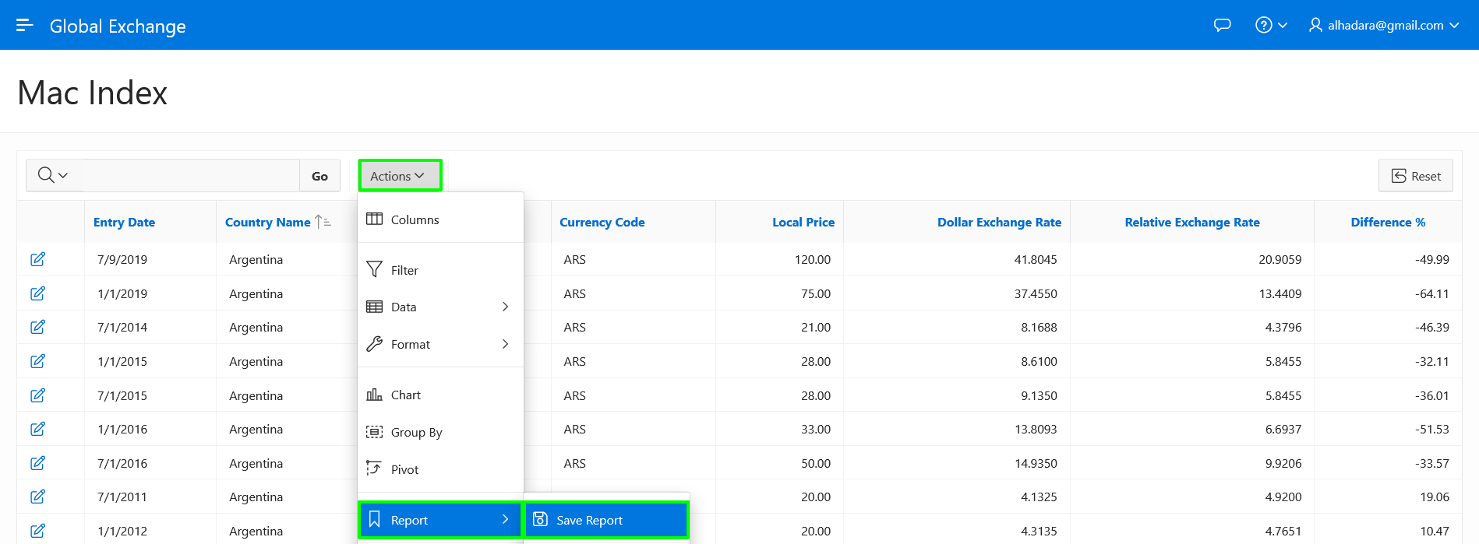

1. In the Save Report dialog, for Save (Only displayed for developers), select **As Default Report Settings**.

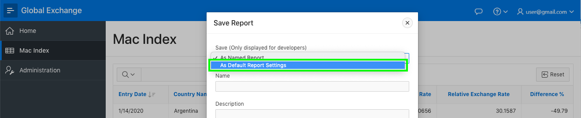

1. In the Save Default Report dialog, click **Apply**.

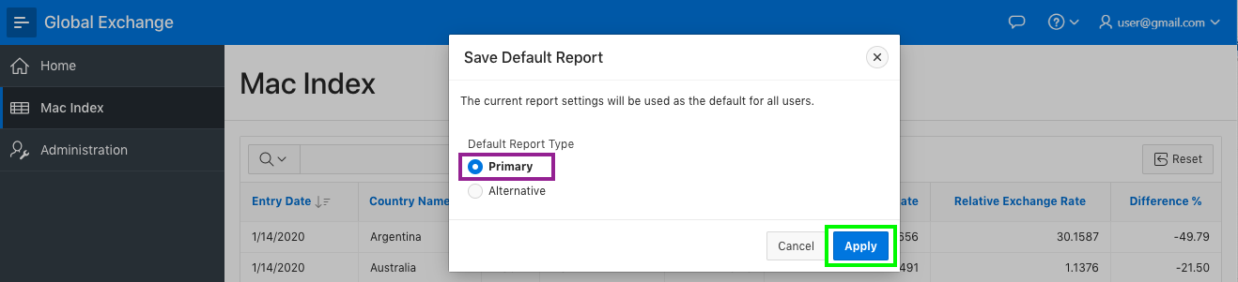

## ****Summary****

This completes Lab 4. In this lab you learnt how to utilize a SQL query as the basis for a report, how to improve how columns are displayed, remove unwanted page elements, manipulate the report layout, and then save it for everyone to utilize.

# Adding a Chart

## Introduction

In this lab, you will learn how to add a chart page to the application.

Estimated Time: 5 minutes

### Background Information

The Big Mac Index includes data for countries over the last 20 years. Therefore, to better visualize trends in a country's exchange rate over time it would be highly beneficial to create a chart that is country specific.

Initially you will create a chart that displays the Dollar Exchange Rate for Australia (COUNTRY_ISO = 'AUS'). Then you will add additional data series.

Collapse All Tasks

## Task 1: Create a New Page

1. From the runtime environment, in The Developer Toolbar (bottom of the screen), click **Application ###**.

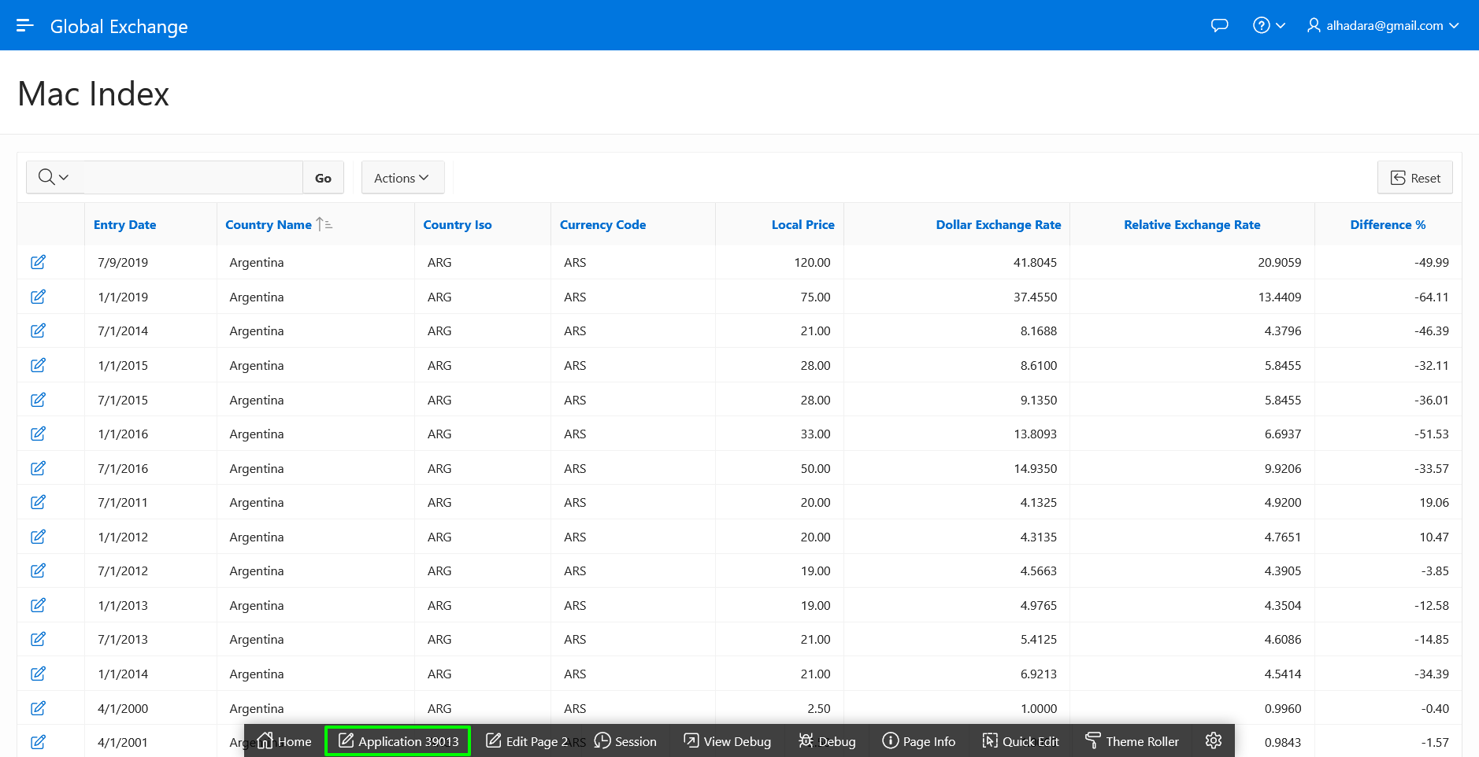

1. From the Application Home Page, click **Create Page**.

In the Create a Page dialog, for Page Type, click **Chart**.

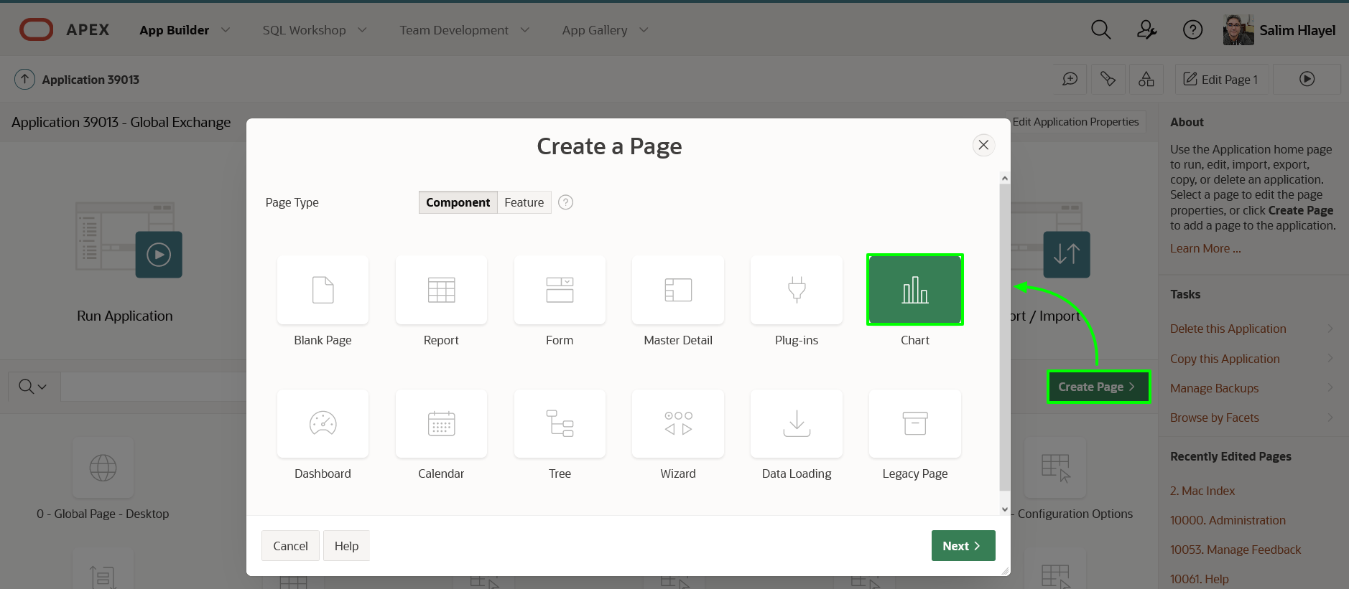

1. In the Create Chart dialog, for Chart Type, click **Line**.

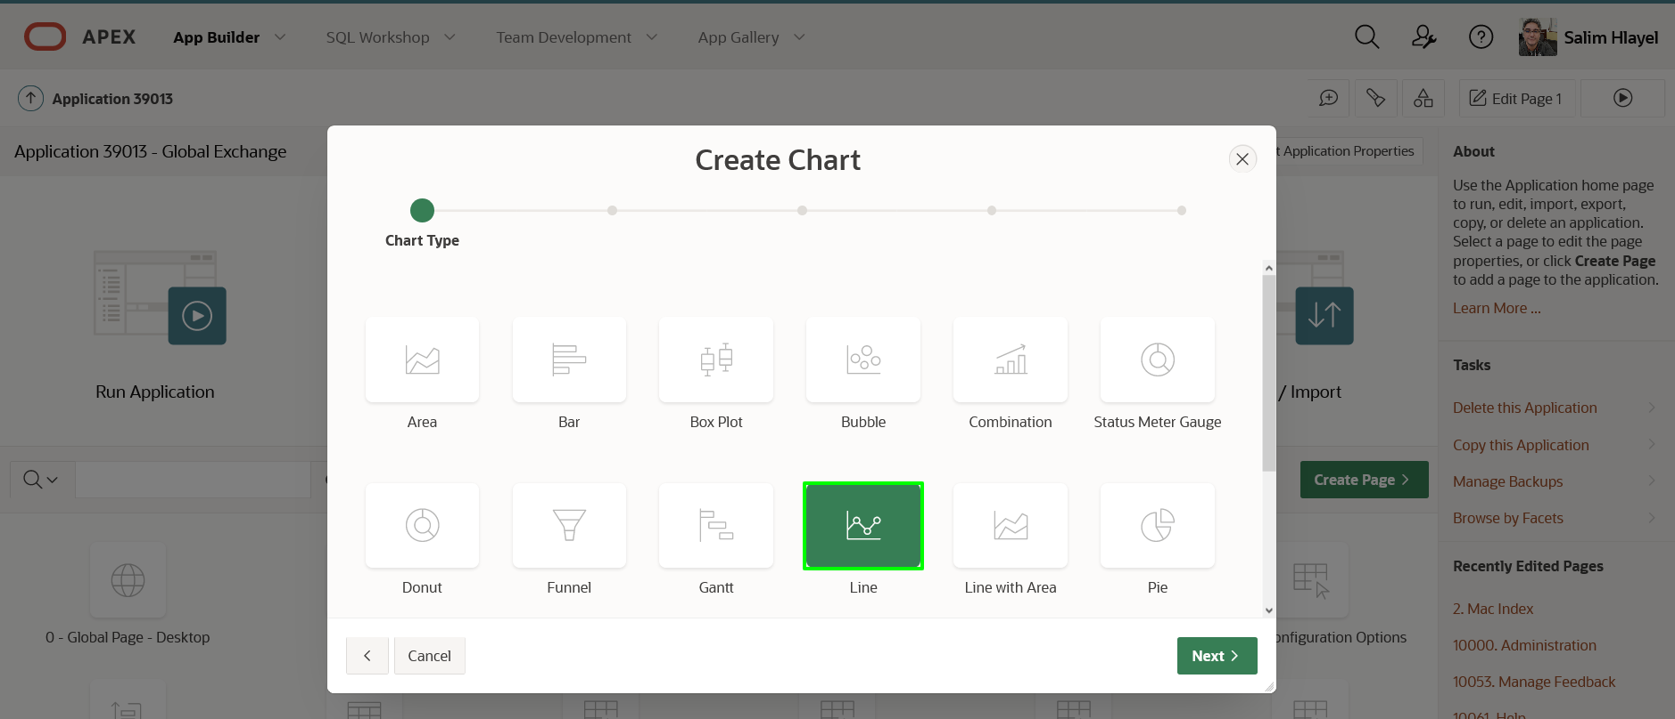

1. In the Page and Region Attributes dialog, enter the following.
   * **Page Name:** enter **Country Chart**
   * **Breadcrumb:** select **Breadcrumb**

Click **Next**.

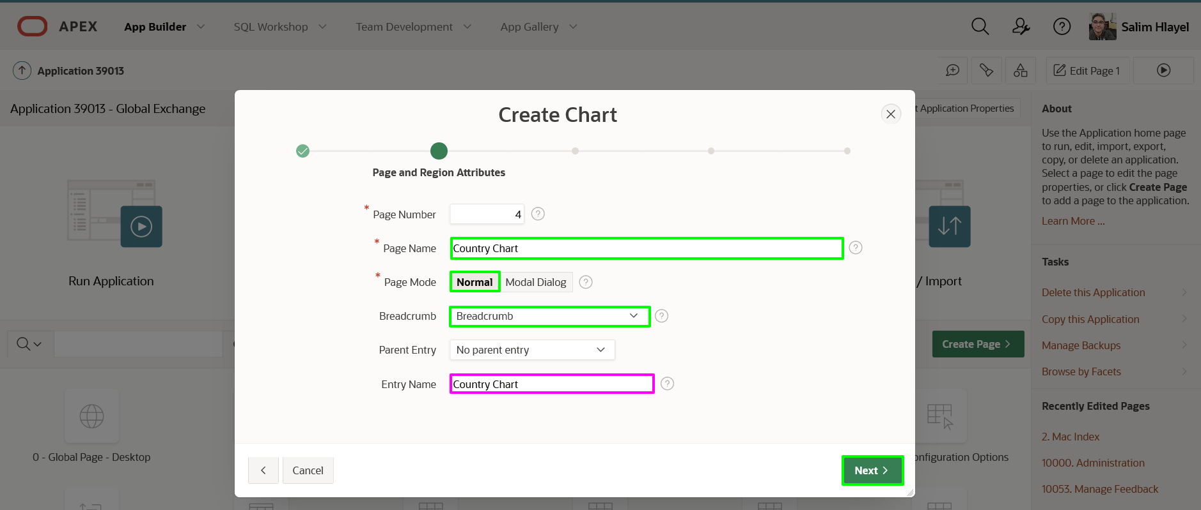

1. In the Navigation Menu dialog, for Navigation Preference, click **Create a new navigation entry**.

Click **Next**.

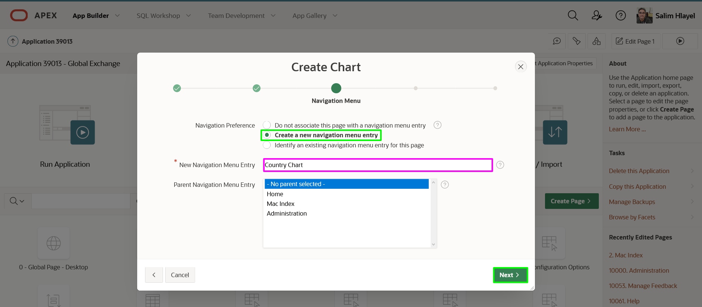

1. In the Source dialog, enter the following.
   * **Source Type:** click **SQL Query**
   * **SQL Query:** cut and paste the following.
   * Copy**select** entry_date
   * , dollar_exchange_rate
   * **from** big_mac_index l
   * **where** country_iso = 'AUS'

**order** **by** entry_date

Click **Next**.

1. 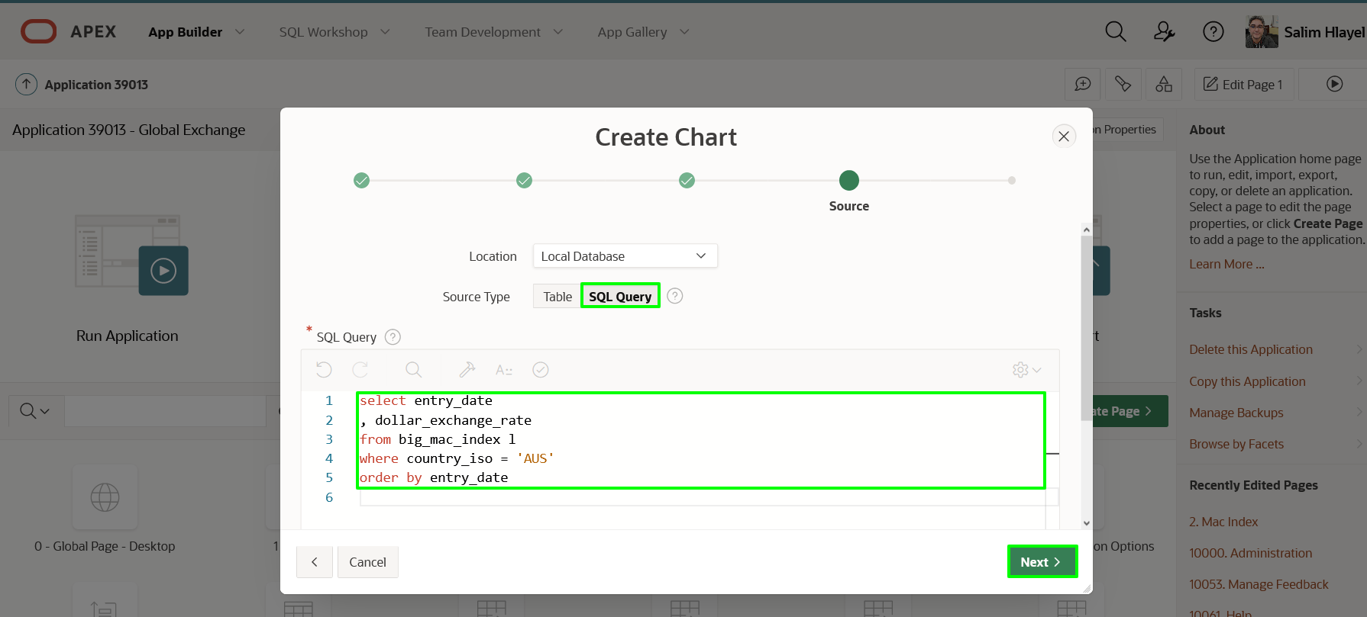
2. In the Column Mapping dialog, enter the following.
   * **Label Column:** select **ENTRY_DATE**
   * **Value Column:** select **DOLLAR_EXCHANGE_RATE**

Click **Create**.

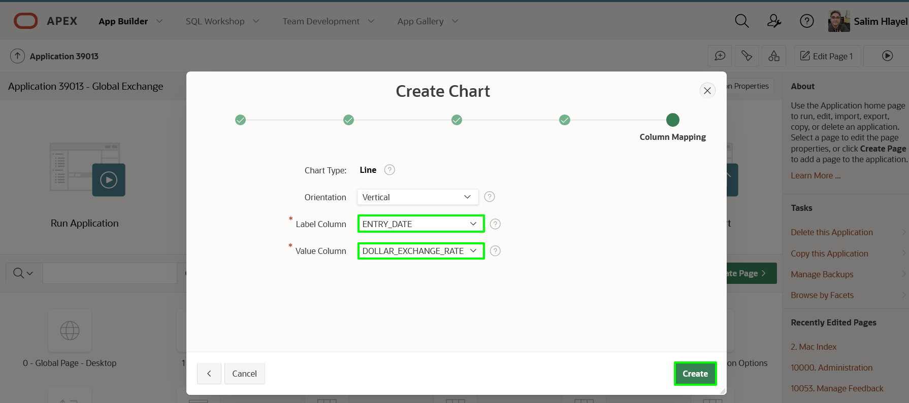

1. In the Page Designer toolbar, click **Save and Run**.

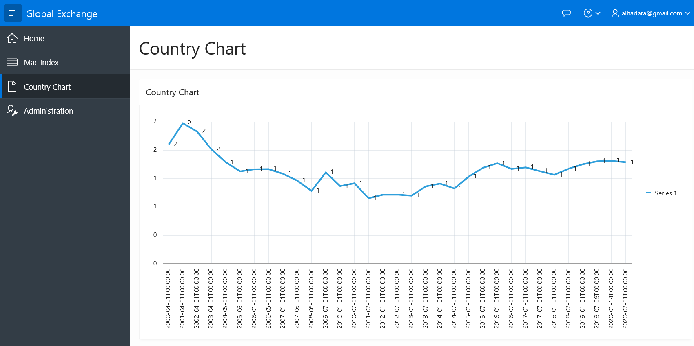

## Task 2: Adjust the Chart Attributes

As can be seen by the appearance of the first cut of the chart, there is work to be done. Updating some attributes will help.

1. From the runtime environment, in the Developer Toolbar (bottom of the screen), click **Quick Edit**. Hover over the chart region until it is surrounded by a blue box. Click the Chart.

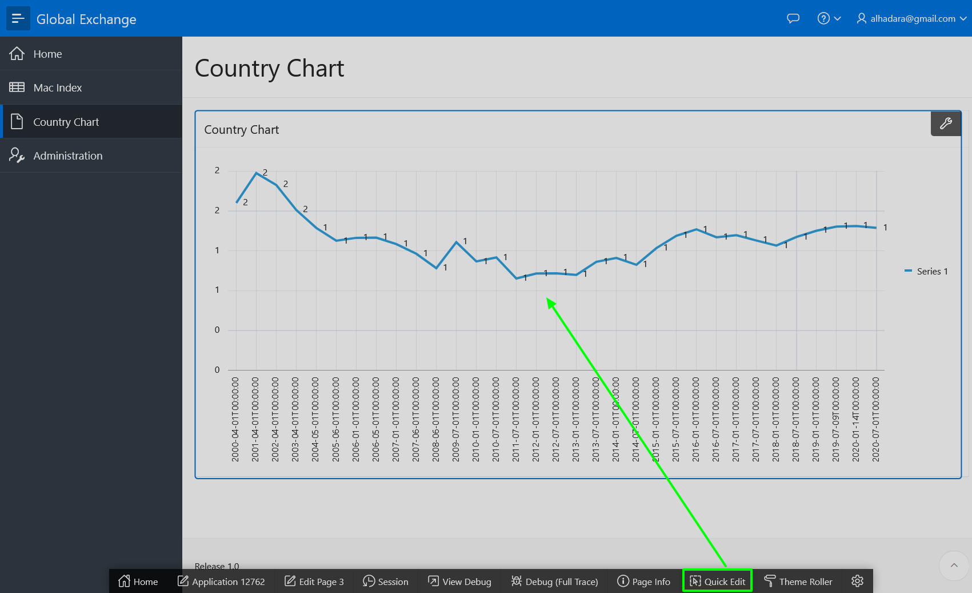

Alternatively, navigate back to the APEX Application Builder tab or window, and then navigate to Page 4.

1. Within Page Designer, in the Rendering tree (left pane), under **Country Chart**, click **Attributes**.

In the Property Editor (right pane), enter the following.

* + **Settings > Time Axis Type:** select **Mixed Frequency**
  + **Legend > Show:** click **Yes**

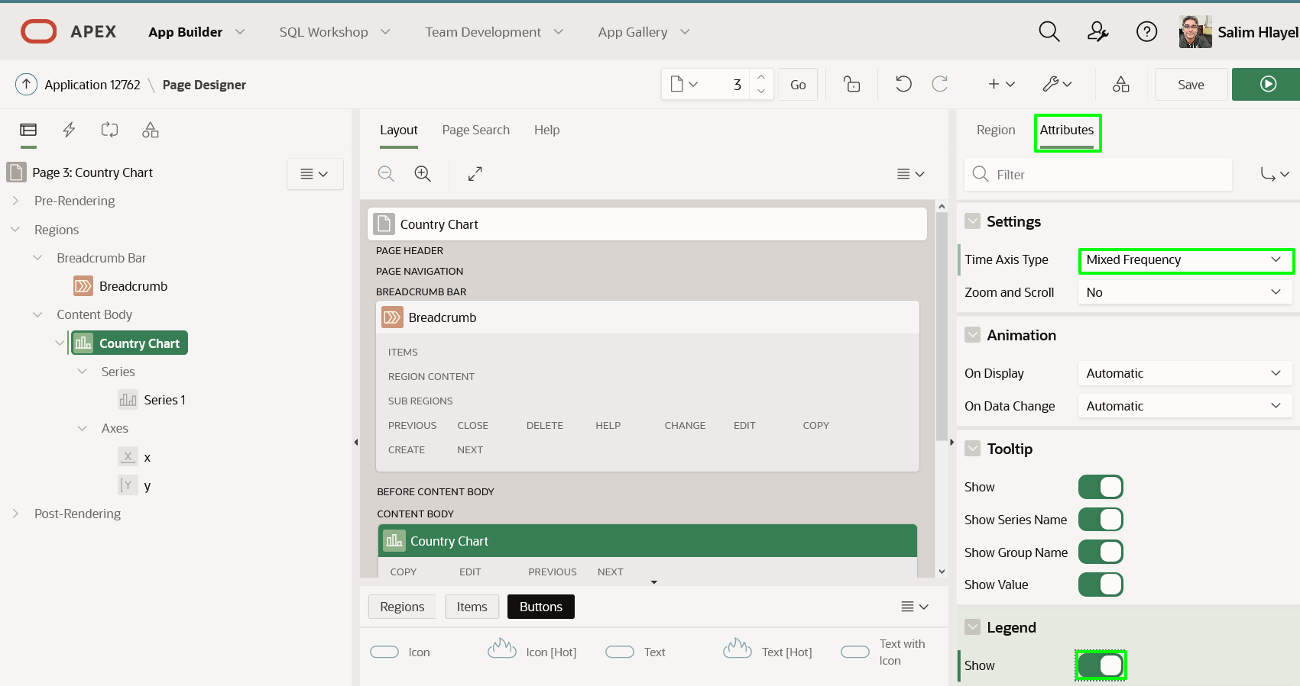

## Task 3: Update the Chart Series

Time to update the existing chart line (series), and add a few more data series.

1. Within Page Designer, in the Rendering tree (left pane), under **Country Chart**, click **Series 1**.

In the Property Editor (right pane), enter the following.

* + **Identification > Name:** enter **Dollar Exchange Rate**
  + **Label > Show:** click **No**

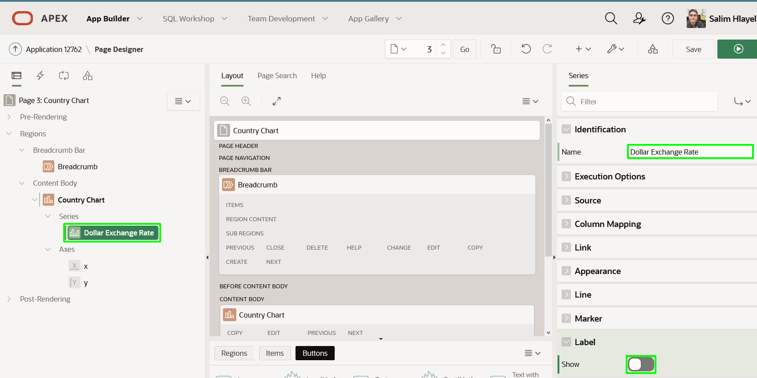

* + Select **Axes > y**
  + **Value > Decimal Places** enter **1**, this will allow the labels on the chart to have decimal values that are more readable.

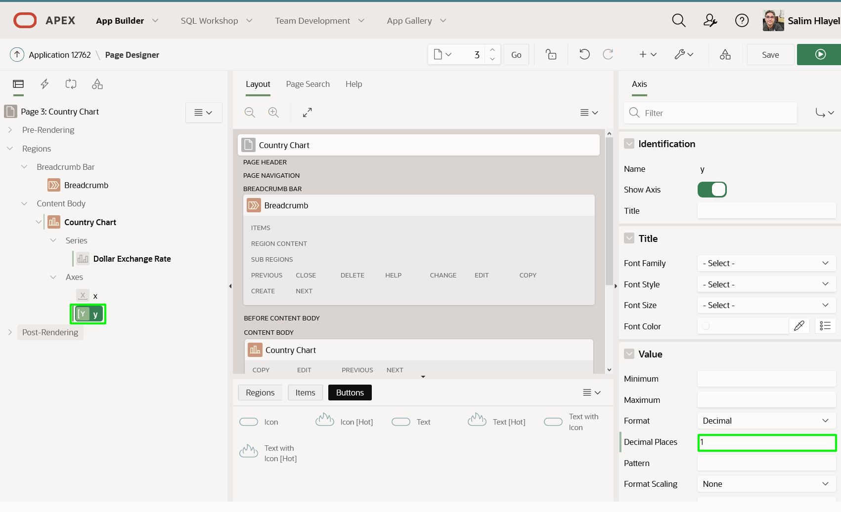

1. The next two series are very similar to the first, so it is easiest to just duplicate the existing series.

In the Rendering tree (left pane), under **Country Chart**, right-click **Dollar Exchange Rate**, click **Duplicate**.

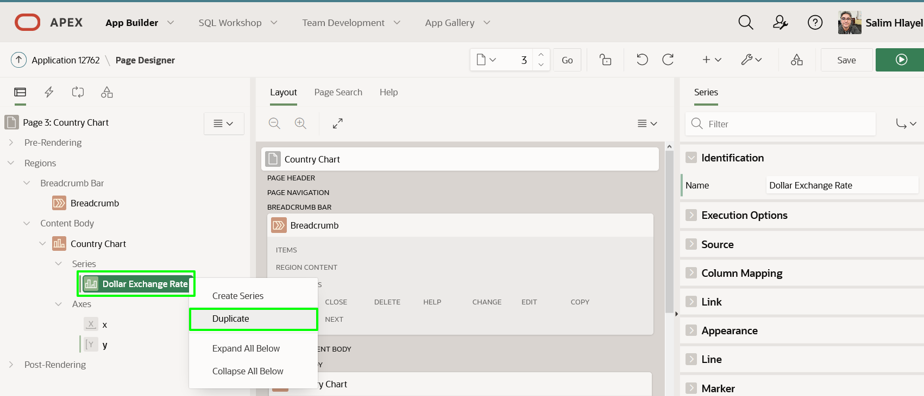

1. Repeat the step above to create a third series. Note: You should now have Dollar Exchange Rate, Dollar Exchange Rate_1, and Dollar Exchange Rate_2 or Dollar Exchange Rate_1_1, depending on which series you duplicated to create the third series.
2. The second chart line (series) is going to display the Relative Exchange Rate.

In the Rendering tree (left pane), under **Country Chart**, click the second series.  
In the Property Editor (right pane), enter the following.

* + **Identification > Name:** enter **Relative Exchange Rate**
  + **Source > SQL Query:** copy and paste the following.
  + Copy**select** entry_date
  + , (local_price / (**select** local_price **from** big_mac_index u
  + **where** u.entry_date = l.entry_date
  + and u.country_iso = 'USA'
  + )
  + ) relative_exchange_rate
  + **from** BIG_MAC_INDEX l
  + **where** country_iso = 'AUS'

**order** **by** entry_date

* + **Column Mapping > Value:** select **RELATIVE_EXCHANGE_RATE**

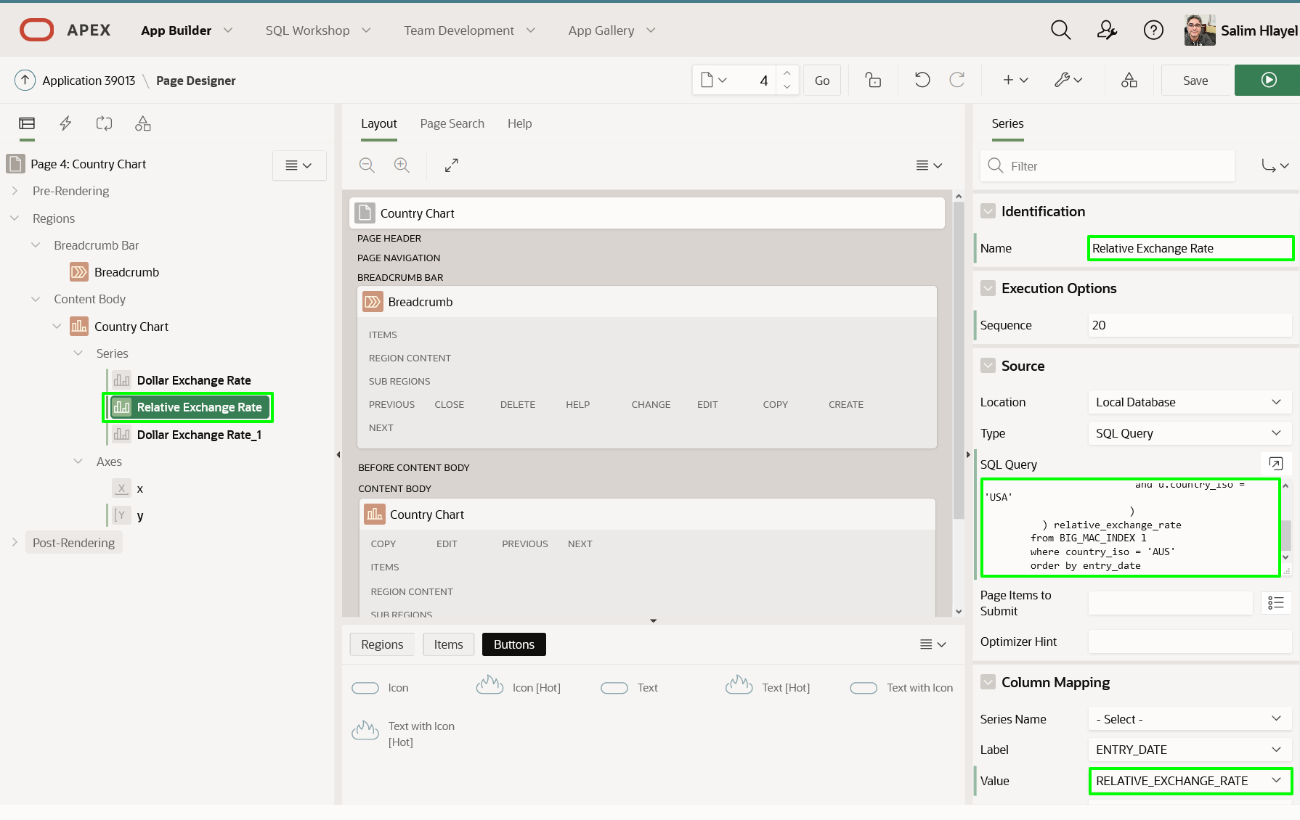

1. The third chart line (series) is going to display the Percentage Difference between the currency and the US currency.

In the Rendering tree (left pane), under **Country Chart**, click the third series.  
In the Property Editor (right pane), enter the following.

* + **Identification > Name:** enter **Percentage Difference (Y2)**
  + **Source > SQL Query:** cut and paste the following:
  + Copy**select** entry_date
  + , (( local_price / (**select** local_price **from** big_mac_index u
  + **where** u.entry_date = l.entry_date
  + and u.country_iso = 'USA'
  + )
  + - dollar_exchange_rate
  + ) * 100 / dollar_exchange_rate
  + ) percentage_difference
  + **from** BIG_MAC_INDEX l
  + **where** country_iso = 'AUS'

**order** **by** entry_date

* + **Column Mapping > Value:** select **PERCENTAGE_DIFFERENCE**
  + **Appearance > Assigned To Y2 Axis:** check **Yes**

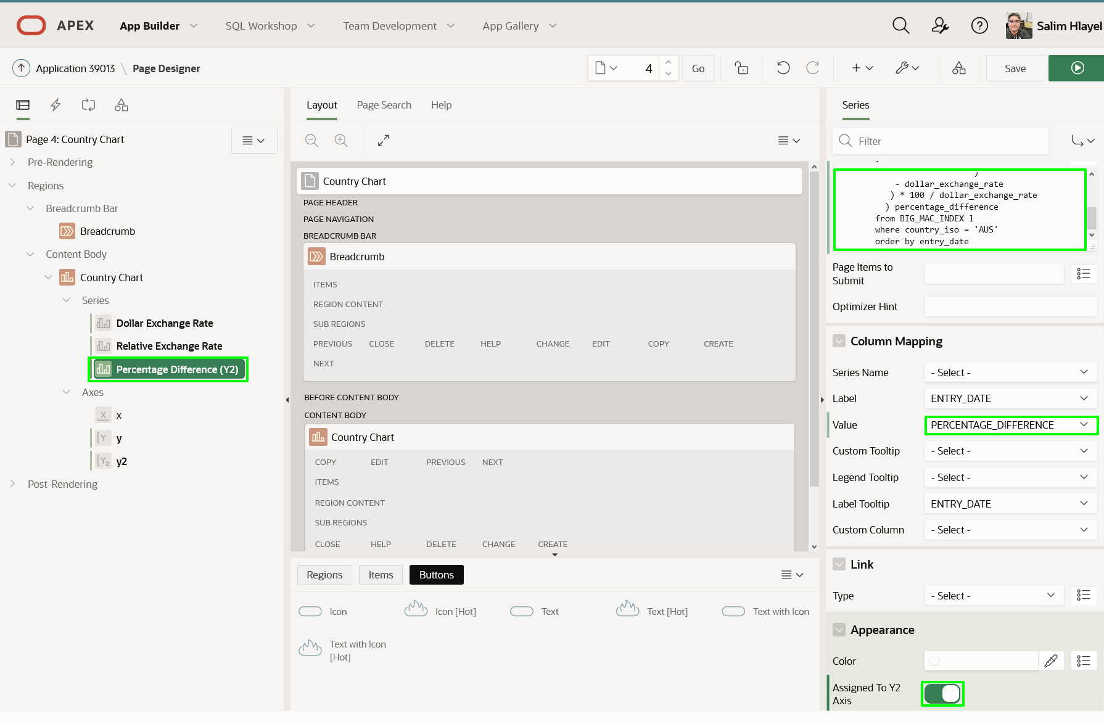

Note: If you do not check ‘Assigned to Y2 Axis’ then the chart will not display well, and not look like the following page.

1. In Page Designer, within the Toolbar, click **Save and Run**.

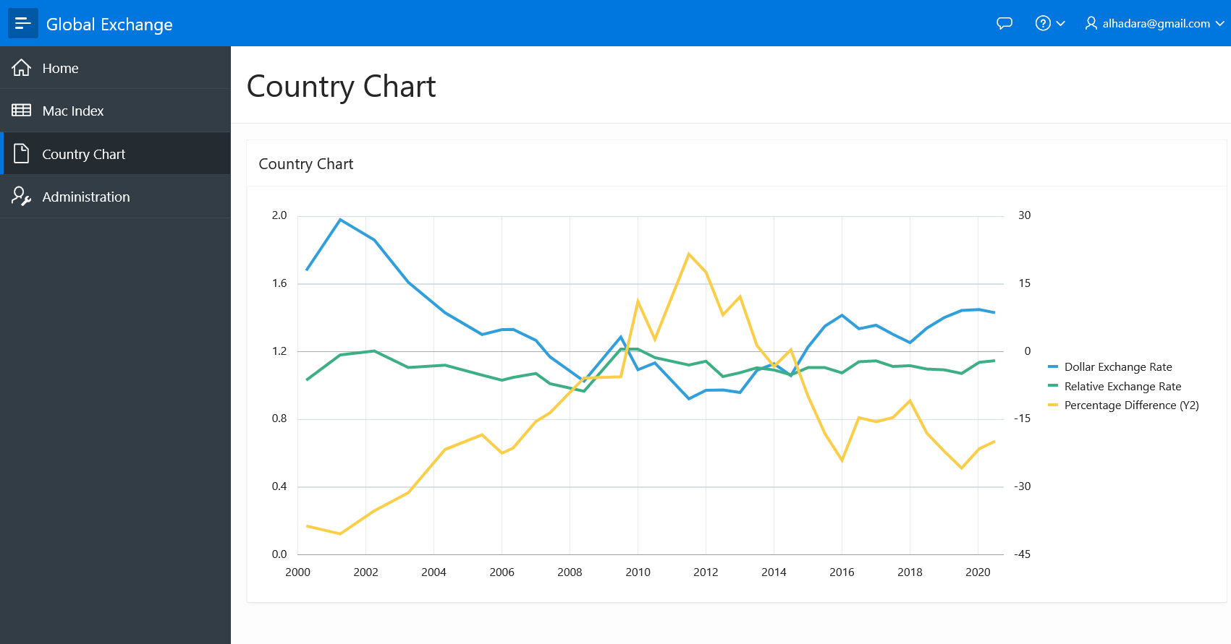

## ****Summary****

This completes Lab 5. In this lab you learnt how to create and modify a chart adding multiple series.

# Adding Chart Criteria

## Introduction

In this lab, you will learn how to add an item to a page, utilize the page item in chart series, and define client-side interactivity.

Estimated Time: 5 minutes

### Background Information

The chart currently has the ISO code for Australia (AUS) hardcoded. By adding a select list with a list of the countries, and then modifying the chart series to utilize this page item you can easily make it easy to review the exchange rate history for any country.

To refresh the chart whenever the country in the select list is changed, you need to utilize a Dynamic Action. A Dynamic Action defines client-side interactivity, and based on a specific action(change in the select list), performs specified functions (refresh), on specified elements (chart region).

In order for the chart to properly utilize the updated value in the select list, then it is necessary to submit that page item when rendering the chart.

Collapse All Tasks

## Task 1: Add a Page Item

1. From the Runtime environment, in the Developer Toolbar (bottom of the screen), click **Edit Page X**.
2. Within Page Designer, in the Gallery (center pane, below Layout), click **Country Chart**, click **Items**. Click **Select List** and hold the mouse down. Drag the item up until it is in the Items section within the Country Chart region. Once the Items section expands and the dark yellow box appears, drop the item (release the mouse).

Note: Make sure that you drag the select list into the Country Chart region.

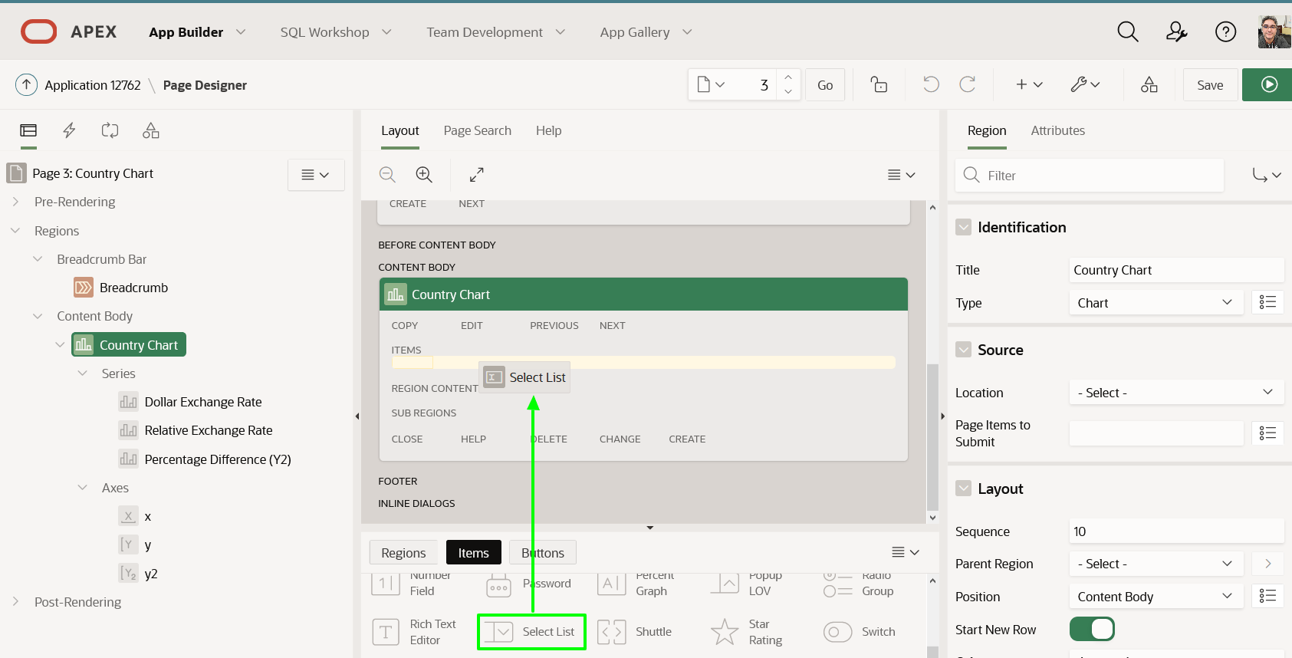

1. In the Property Editor (right panel), update the following.
   * **Identification > Name:** enter **P3_COUNTRY**
   * **List of Values > Type:** select **SQL Query**
   * **List of Values > SQL Query:** cut and paste the following.
   * Copy**select** **distinct** country_name d, country_iso r
   * **from** big_mac_index

**order** **by** 1

* + **List of Values > Display Extra Values:** click **No**
  + **List of Values > Null Display Value:** enter **Select Country -**

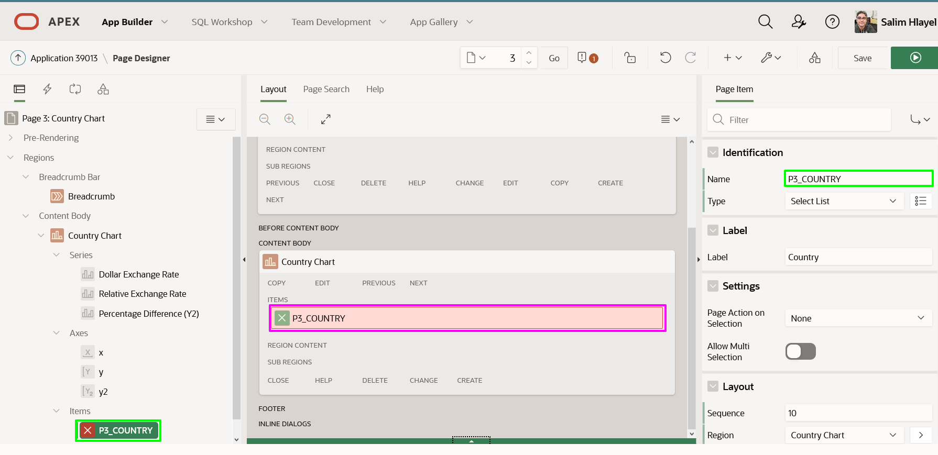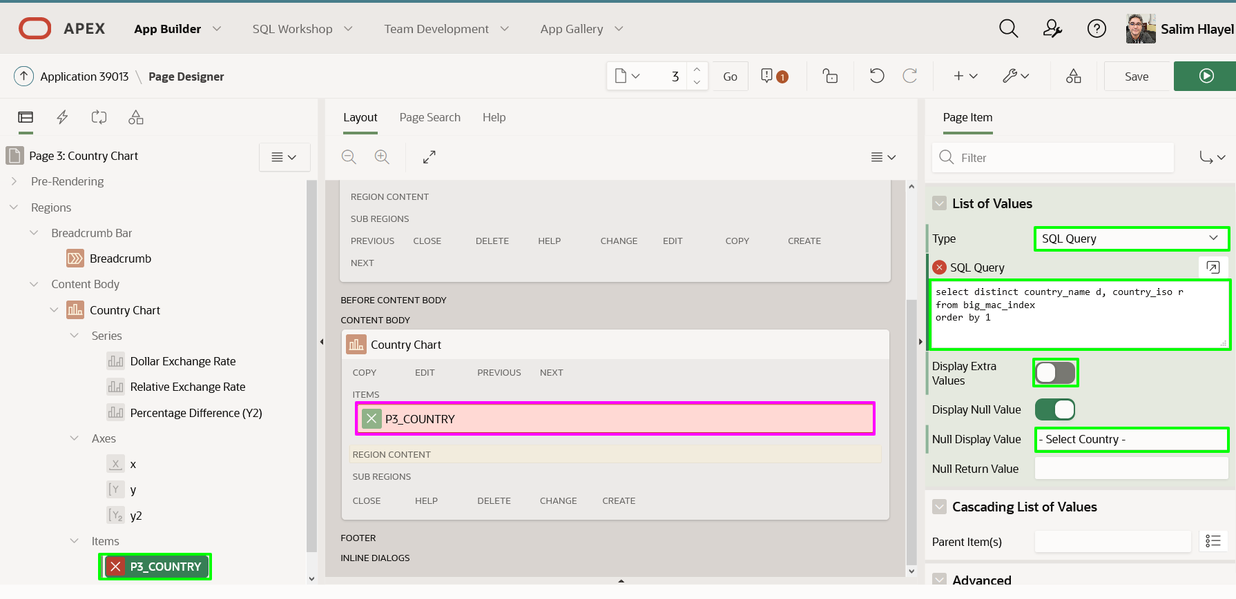

## Task 2: Add a Dynamic Action

In order for the chart to be refreshed when a country is selected from the new item a Dynamic Action must be defined.

1. In the Rendering tree (left pane), right click on **P3_COUNTRY**, select **Create Dynamic Action**.

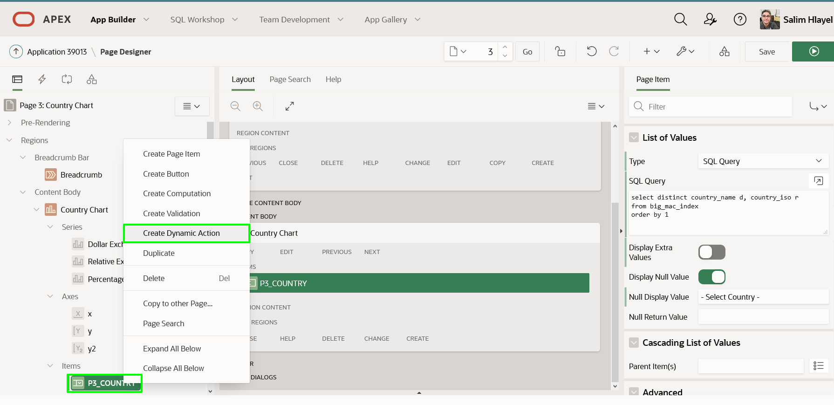

1. In the Property Editor (right pane), for Identification > Name, enter **Refresh Chart**.

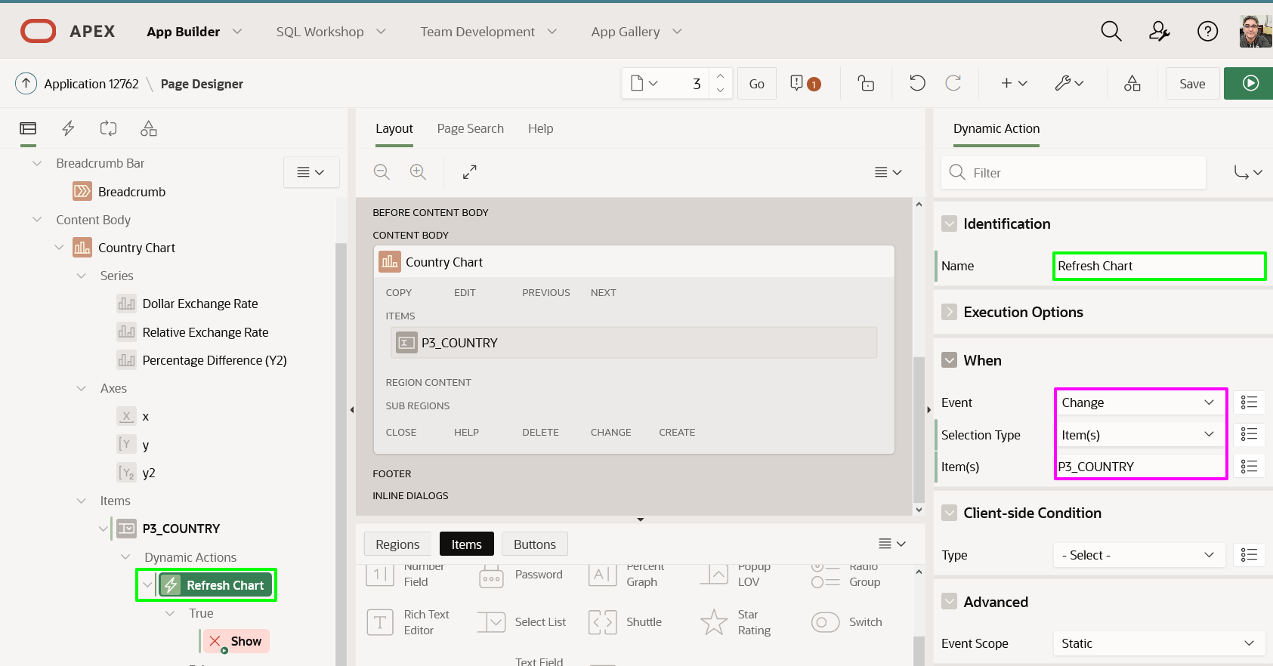

1. In the Rendering tree (left pane), under Dynamic Actions > True, click **Show**.

In the Property Editor (right pane), enter the following.

* + **Identification > Action:** select **Refresh**
  + **Affected Elements > Selection Type:** select **Region**
  + **Affected Elements > Region:** select **Country Chart**

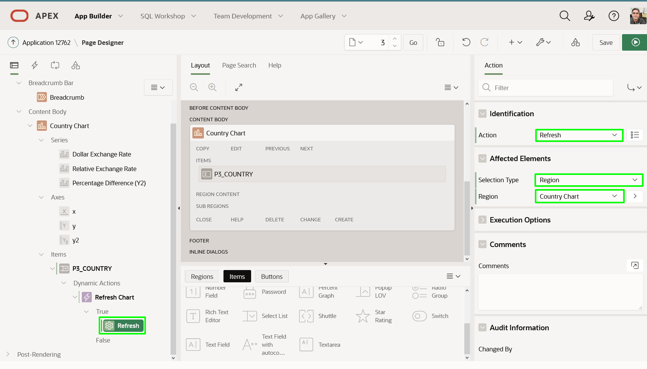

## Task 3: Update the Chart

Currently, all three chart series have the country hard-coded. To ensure the value from the item can be used it must be set in session state. Rather than doing this in each series you can set it once for the chart. Once the item is in session state then it can be utilized in the where condition within each chart series.

1. In the Rendering tree (left pane), under Content Body, click **Country Chart**.

In the Property Editor (right pane), for Source > Page Items to Submit, select **P3_COUNTRY**.

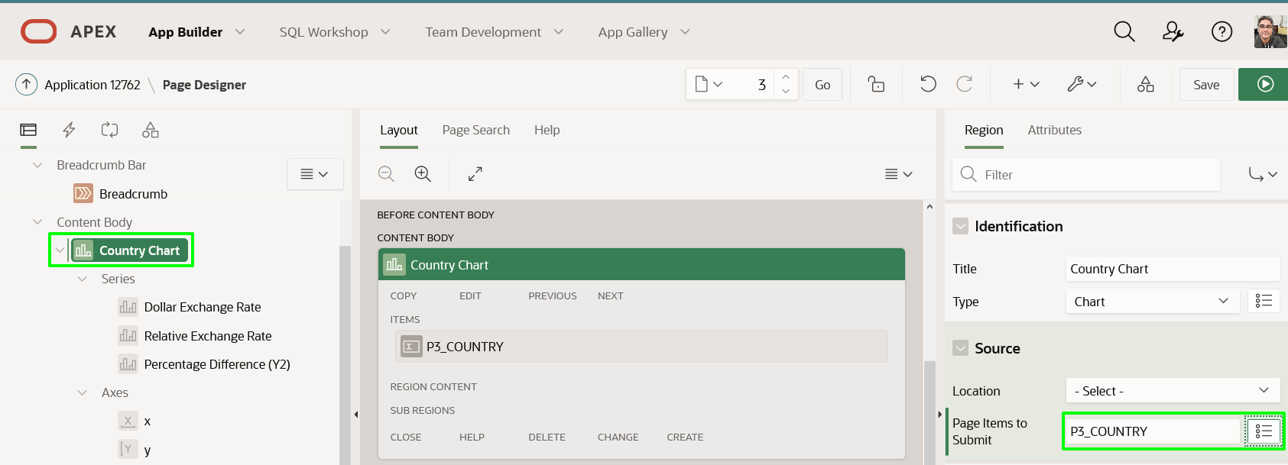

1. In the Rendering tree (left pane), under Series, click **Dollar Exchange Rate**.

In the Property Editor (right pane), for Source > SQL Query, replace **'AUS'** with **:P3_COUNTRY**.

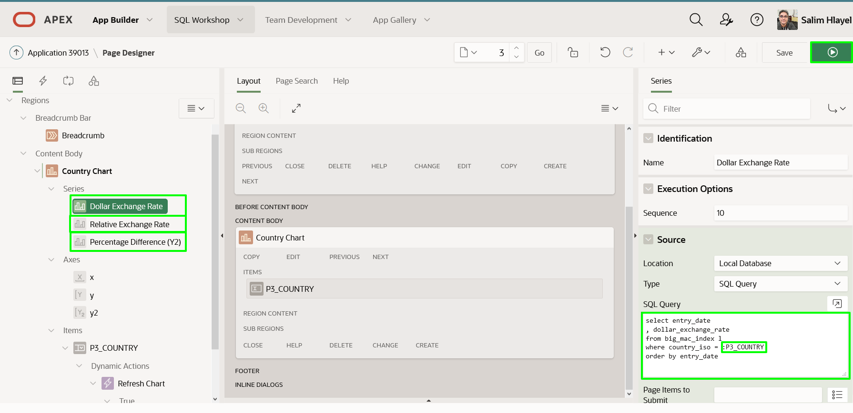

1. In the Rendering tree (left pane), under Series, click **Relative Exchange Rate**. In the Property Editor (right pane), for Source > SQL Query, replace **'AUS'** with :**P3_COUNTRY**.
2. In the Rendering tree (left pane), under Series, click **Percentage Difference**. In the Property Editor (right pane), for Source > SQL Query, replace **'AUS'** with :**P3_COUNTRY**.

## Task 4: Improve the Chart Page

1. In Page Designer, within the Toolbar, click **Save and Run**.
2. In the Runtime environment, select different Countries.

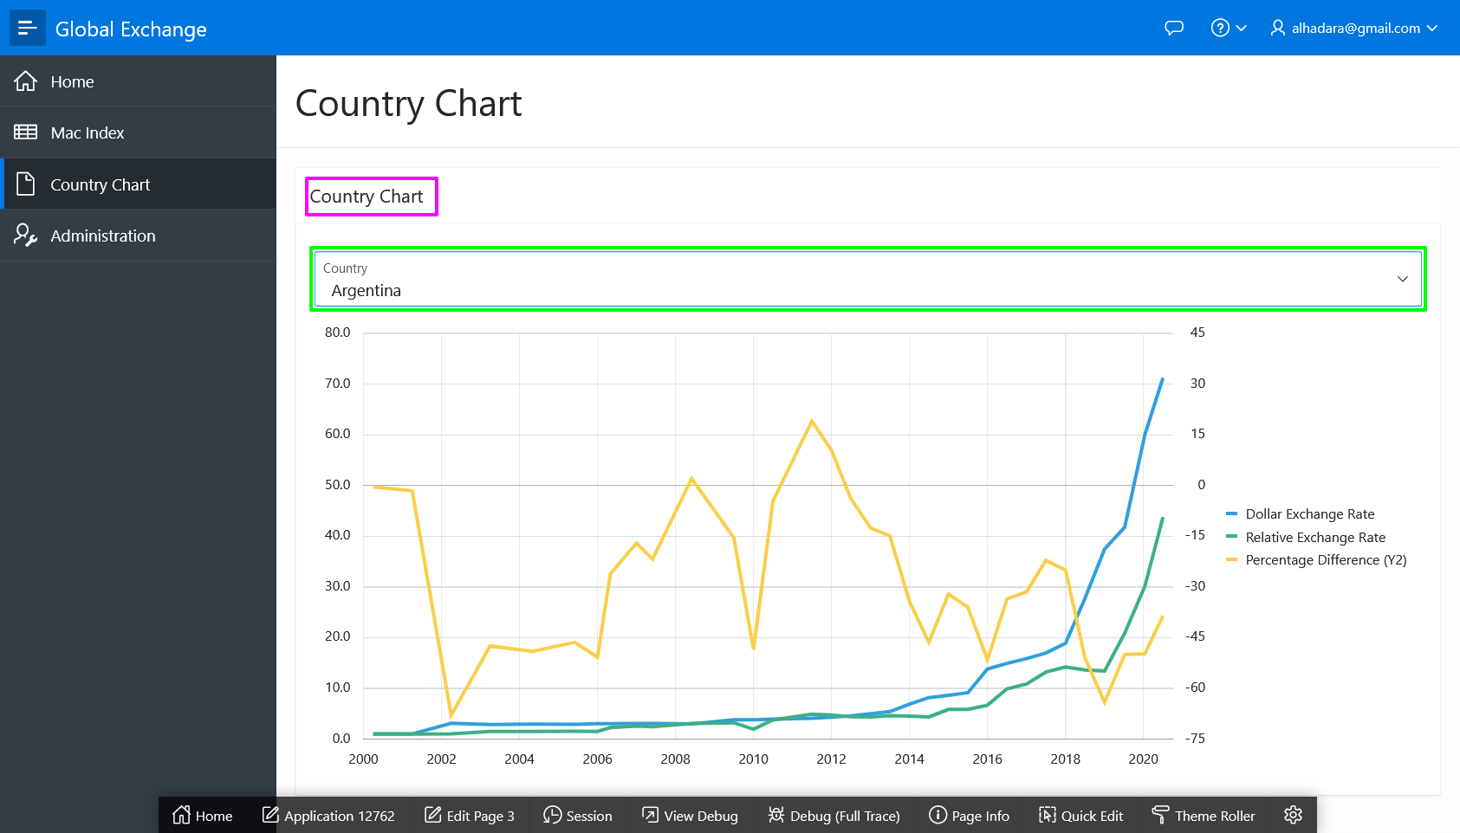

1. Reviewing the runtime environment the region name should be hidden. This can be done from the runtime environment using Live Template Options.

In the runtime environment, within the Developer Toolbar, click **Quick Edit**. Move the mouse up until a blue outline surrounds the chart. Click the **Wrench** in the top right corner of the chart region.

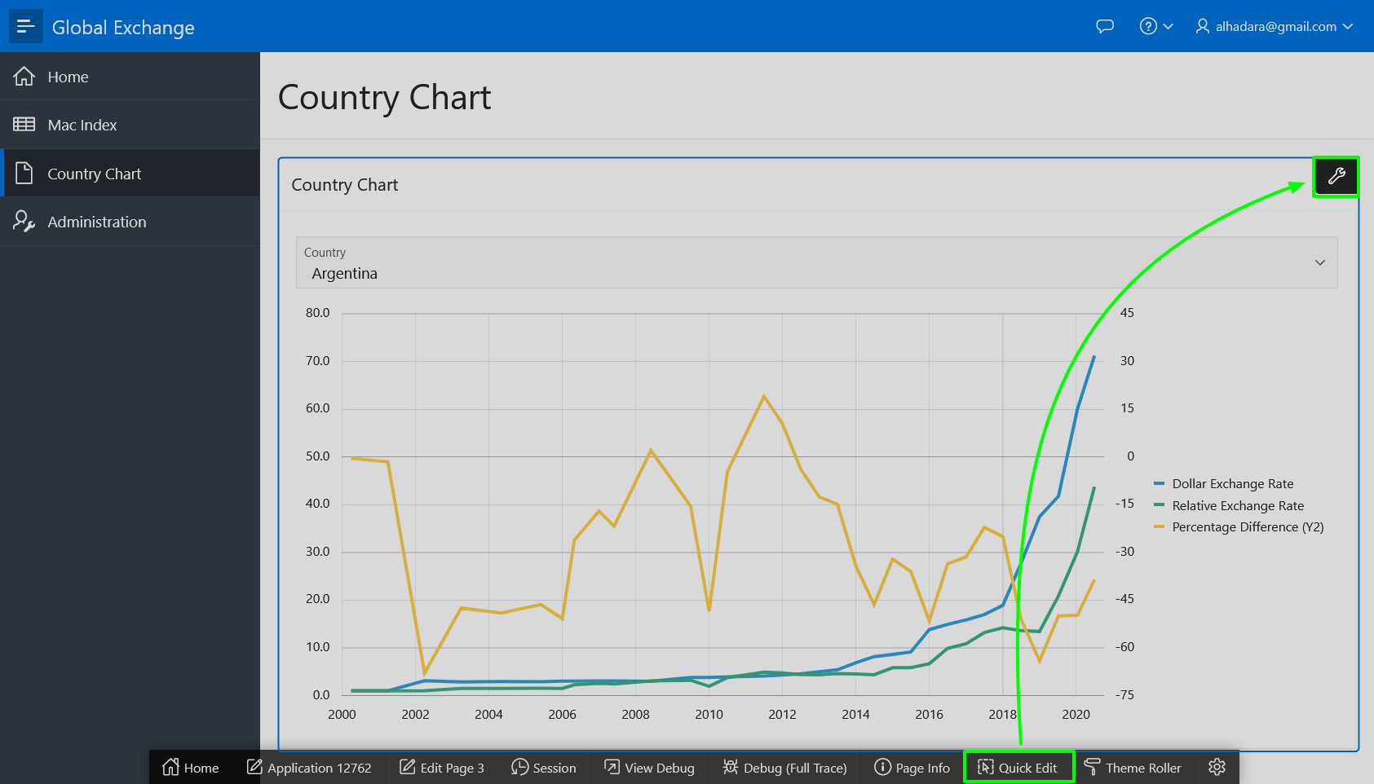

1. In the Live Templates Options dialog, for Header, select **Hidden but accessible**.  
   Note: If an end user is using assistive technology then the region name will be announced.

Click **Save**.

1. In the Runtime environment, select different Countries.

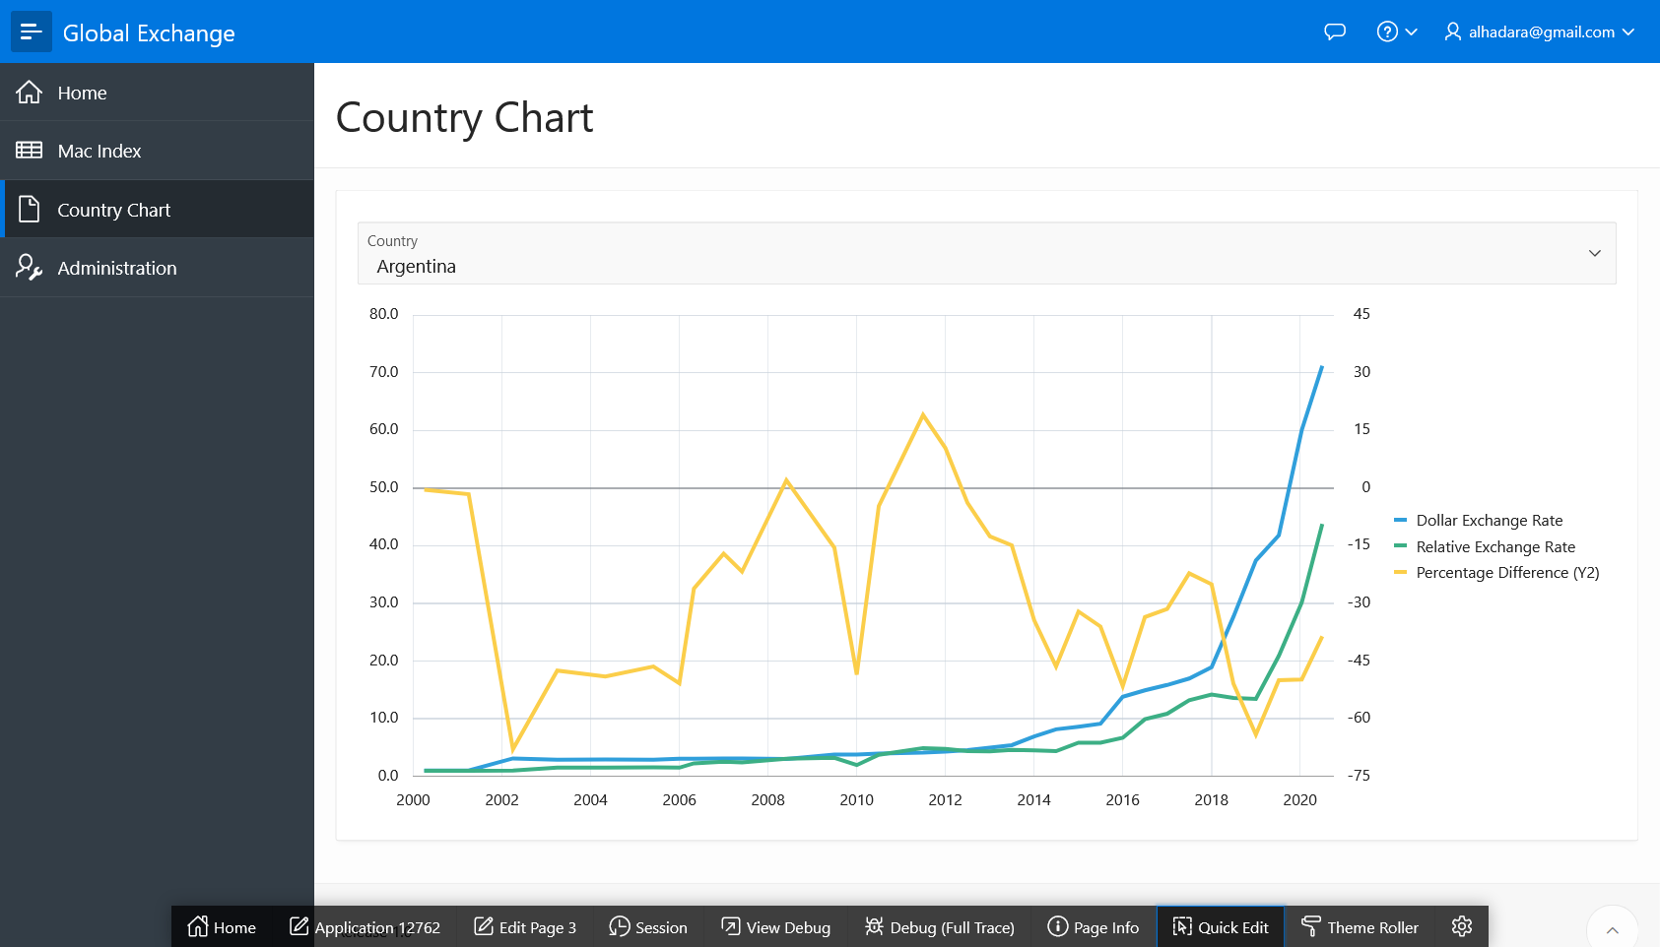

## ****Summary****